Education, Health and Care Hub Documentation



EHC Hub Easy Parents’ Guide

Date: February 2023

Version: v1.1

The Needs Assessment Request Process

Completing a Needs Assessment Request

**How do I request an EHC Needs Assessment?**

In Nottinghamshire, we ask that, wherever possible, parents discuss an EHC needs assessment request with their school/educational setting. The educational setting will be able to support you and ensure the request is completed as fully as possible. However, a parent/carer or a young person (if over 16yrs) can also [request an EHC Needs Assessment](https://ehchub.nottinghamshire.gov.uk/about/) directly through the EHC Digital Hub themselves.

**We recommend** that the next steps are to:

* arrange a meeting with a professional in the school/education setting, usually the SENCO
* decide if you and/or the school/education setting wish to make an EHC needs assessment request

If a decision has been made to proceed with an EHC needs assessment, this can be completed through the [EHC Digital Hub](https://ehchub.nottinghamshire.gov.uk/about/)

**How to complete the request**

To make a request click/go to the below link:

<https://ehchub.nottinghamshire.gov.uk/about/>

The following page will appear: 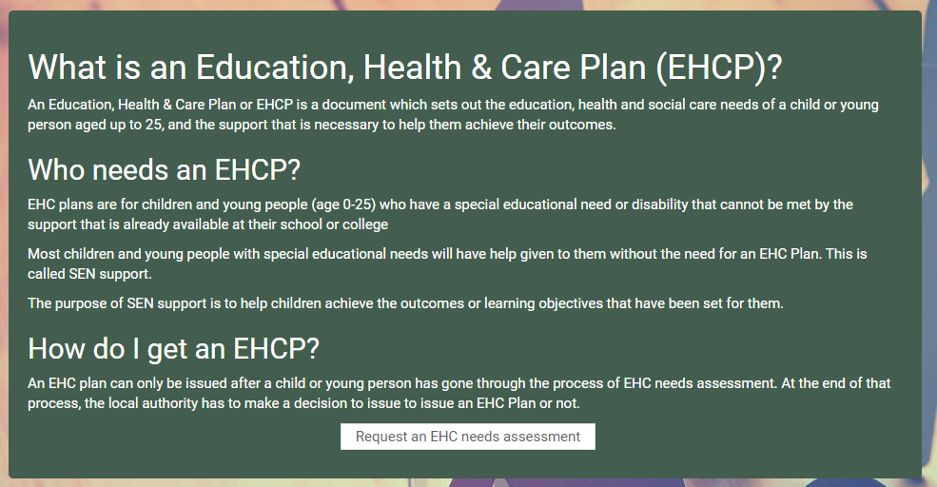

Click on the Request an EHC Needs Assessment button at the bottom of the page

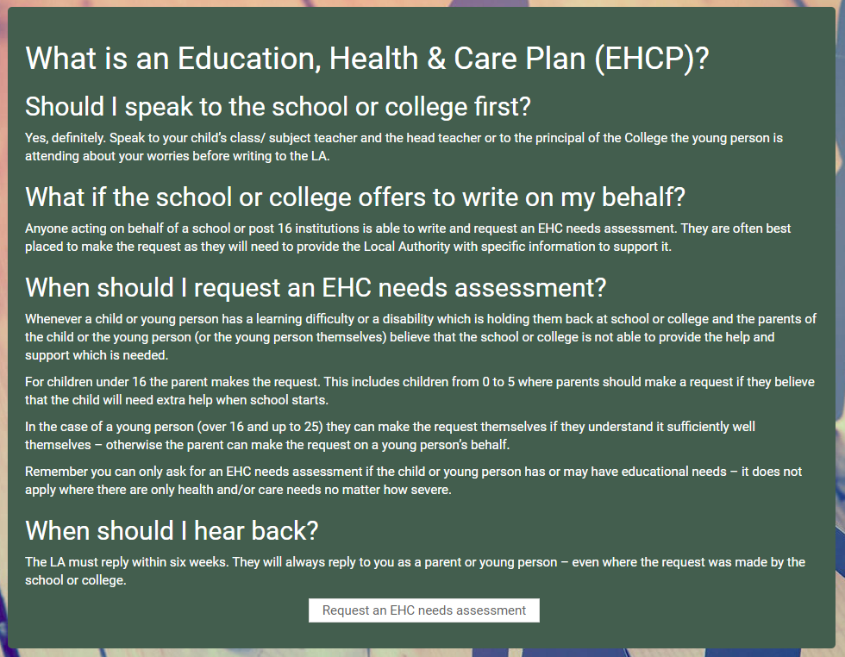

Click on Request an EHC Needs Assessment to request an assessment

It is not possible to save or upload documents at this point

The following page will appear:

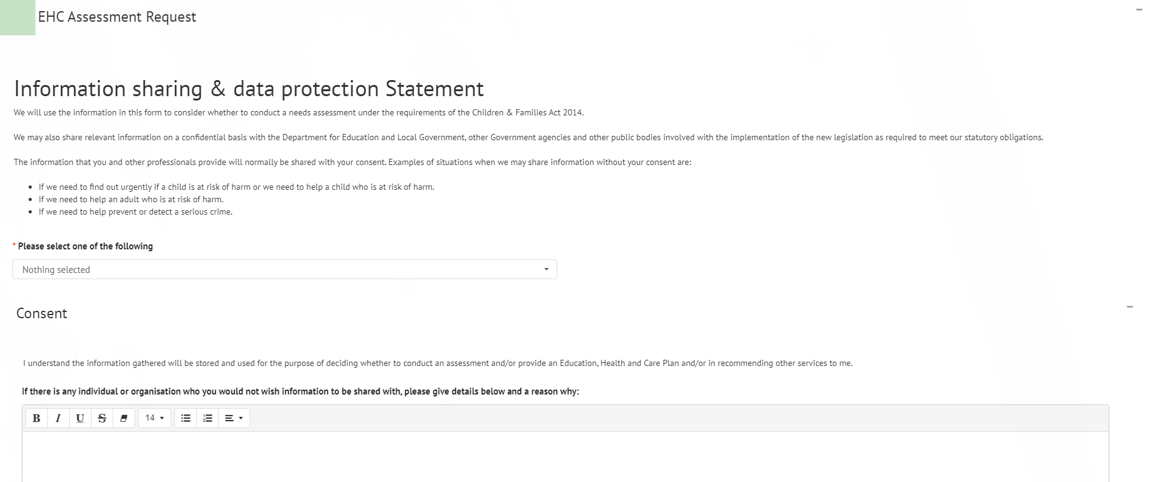

**Consent**

When giving consent, if there are any individuals or organisations that you do not wish information concerning the assessment to be shared with, details as to who and why can be entered here. Click here for more information on using free text fields.

Consent - Left click on the tick box to give consent. You will be unable to send the request for an assessment unless consent is given.

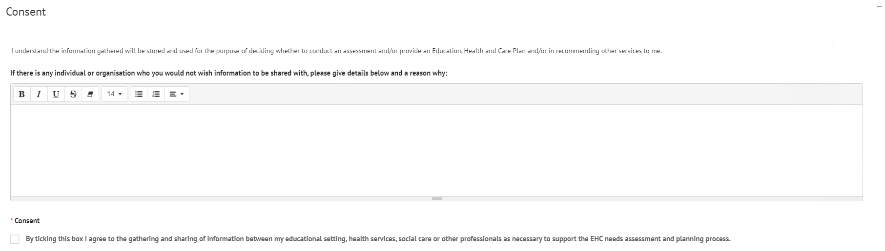

**Complete all the sections**

All sections with a red asterisk * are compulsory fields and will require completing before you send the request.

When all the required information has been entered, click on Send Request

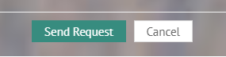

Once completed you will see the ‘Thank you for your request’ screen

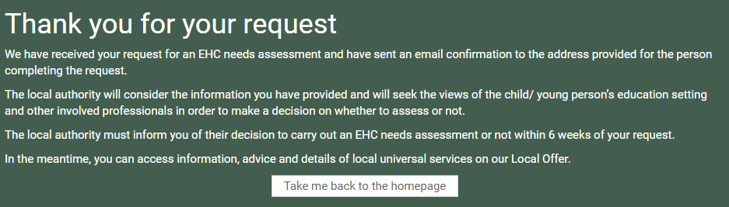

How to Register for an Account

Once the request has been sent to the local authority, they will contact you by email to register on the EHC Hub so you can access and amend the details of the request and upload any documents if required.

There is a second level of security (known as two factor authentication) which will involve the entering of a six-digit code provided to you either by a text message or an authentication app.

You will receive an email that looks like this:

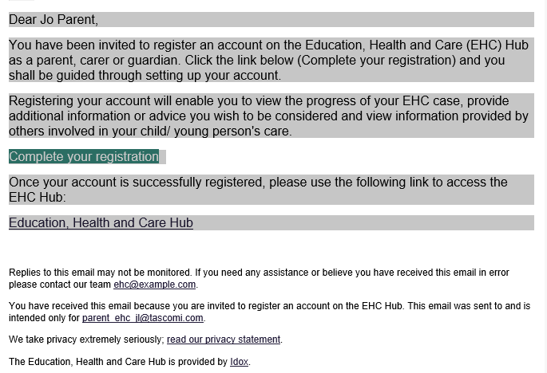

Click on the Complete your registration link in the email. The following page will appear:

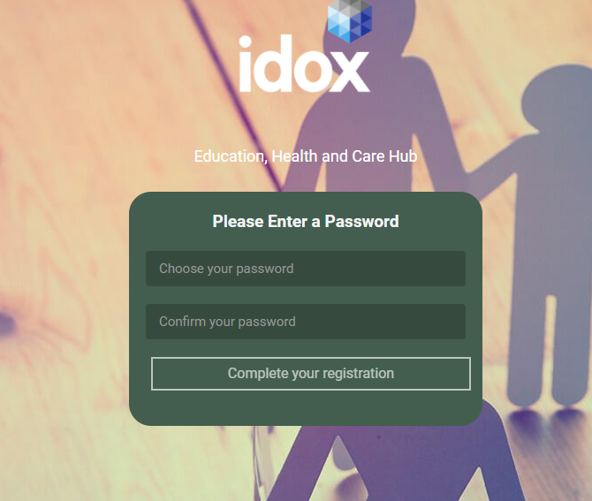

Create a password for your EHC Hub account and click on Complete your registration

When logging in your username will be your email address.

If you have any problems when logging in, please contact the required duty desk:

**Bassetlaw and Newark & Sherwood areas:** [icdsehcBandNSlocality@nottscc.gov.uk](mailto:icdsehcBandNSlocality@nottscc.gov.uk)

**Mansfield and Ashfield areas:** [icdsehcMandAlocality@nottscc.gov.uk](mailto:icdsehcMandAlocality@nottscc.gov.uk)

**Broxtowe, Gedling and Rushcliffe areas:** [icdsehcBGRlocality@nottscc.gov.uk](mailto:icdsehcBGRlocality@nottscc.gov.uk)

**Post 16:** icdsehcpost16@nottscc.gov.uk

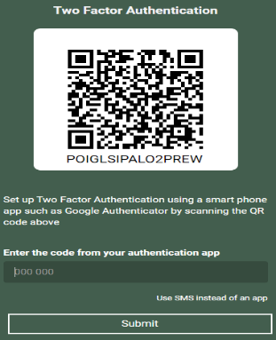Once your username and password have been entered correctly, the following page will be displayed:

SMS Authentication

We suggest using the SMS (text) method for ease, click on ‘use SMS instead of an app’.

The following page will appear:

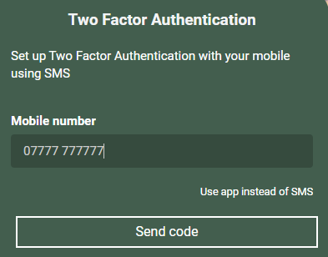

Enter the mobile number you want the code to be sent to.

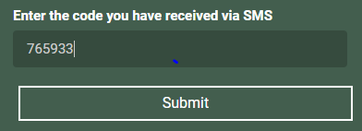

Enter the code that is sent to your phone and click on Submit.

When you have successfully logged into the EHC Hub, the welcome page will then be displayed:

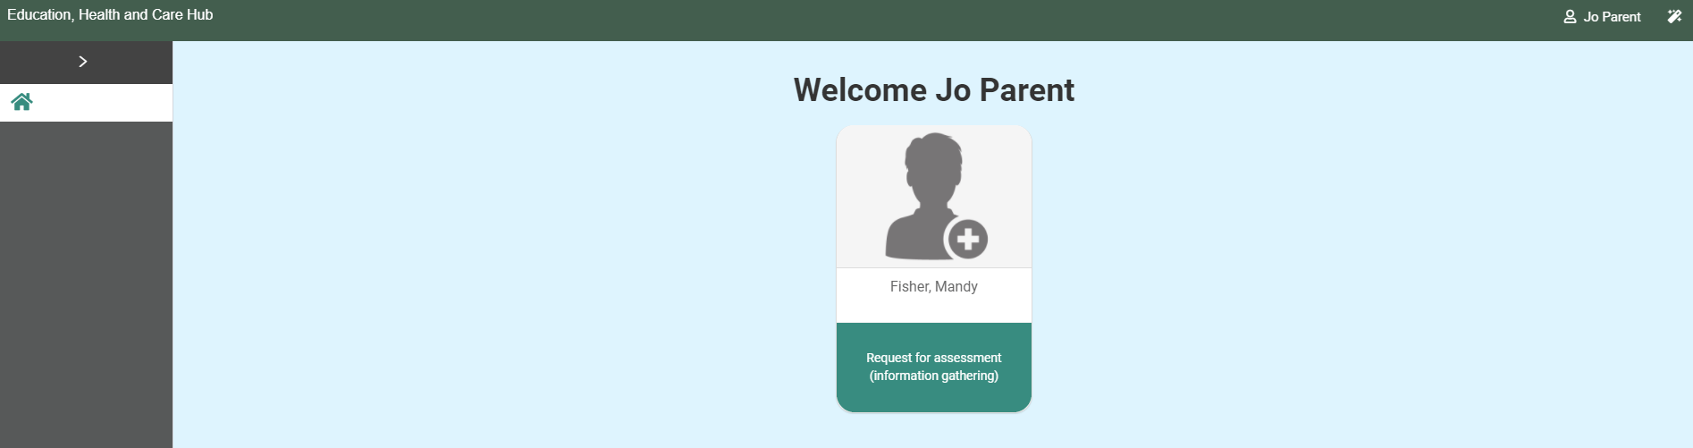

Viewing the Request for Assessment

When you log into the EHC Hub, you will see the icon for the case for the child or young person:



Left click anywhere on this icon to open and display the information in it. The following page will appear:

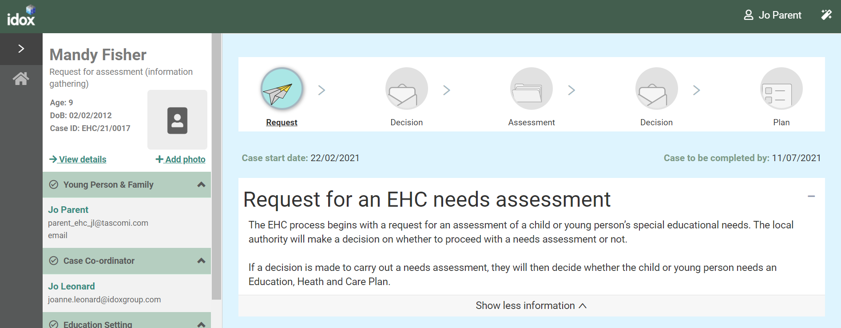

Status of the Process

The top of the screen will show what stage of the process the EHC plan is currently at.

**Request** – this means a request for a EHC needs assessment has been made and information is being gathered to decide if a needs assessment should take place:

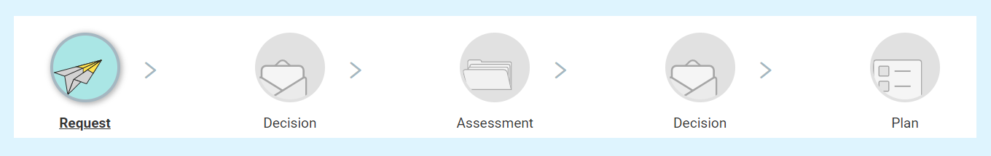

Details of the Case

The left-hand side of the screen can be used to access different parts of the case record.

These different sections are Young Person and Family, Case Co-ordinator, Education Setting, Notes & Timeline and Key Dates.

You can expand each section to view information on it by clicking on the green header of the section or on the arrow at the end of each section header:

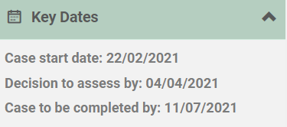

How to contribute to a request

Once the request has been made, there are various things that you can do to contribute to the request. Some of the information can be amended or added to here by you, but some information can only be amended by the case co-ordinator.

If you want to change information in an area that can only be amended by the case co-ordinator, you should email the case co-ordinator with the request.

The details of the case co-ordinator, including their email address are displayed on the left-hand side of the screen:

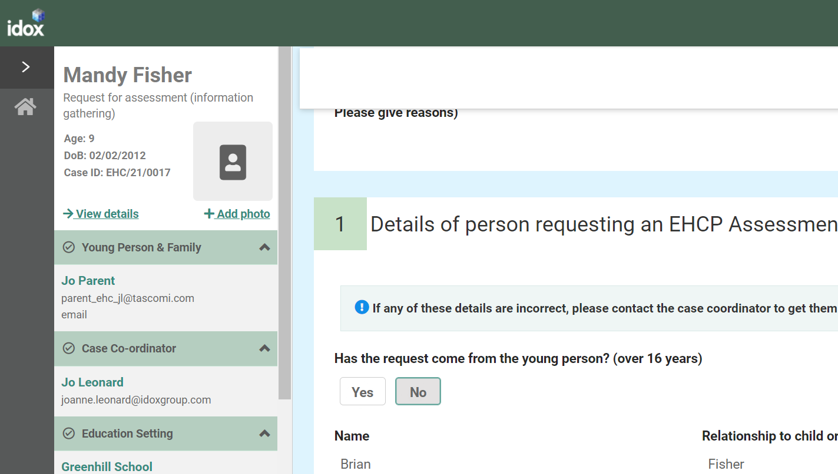

If you do make any changes to those sections that can be amended, you will need to click on Save changes to save at the top of the screen:

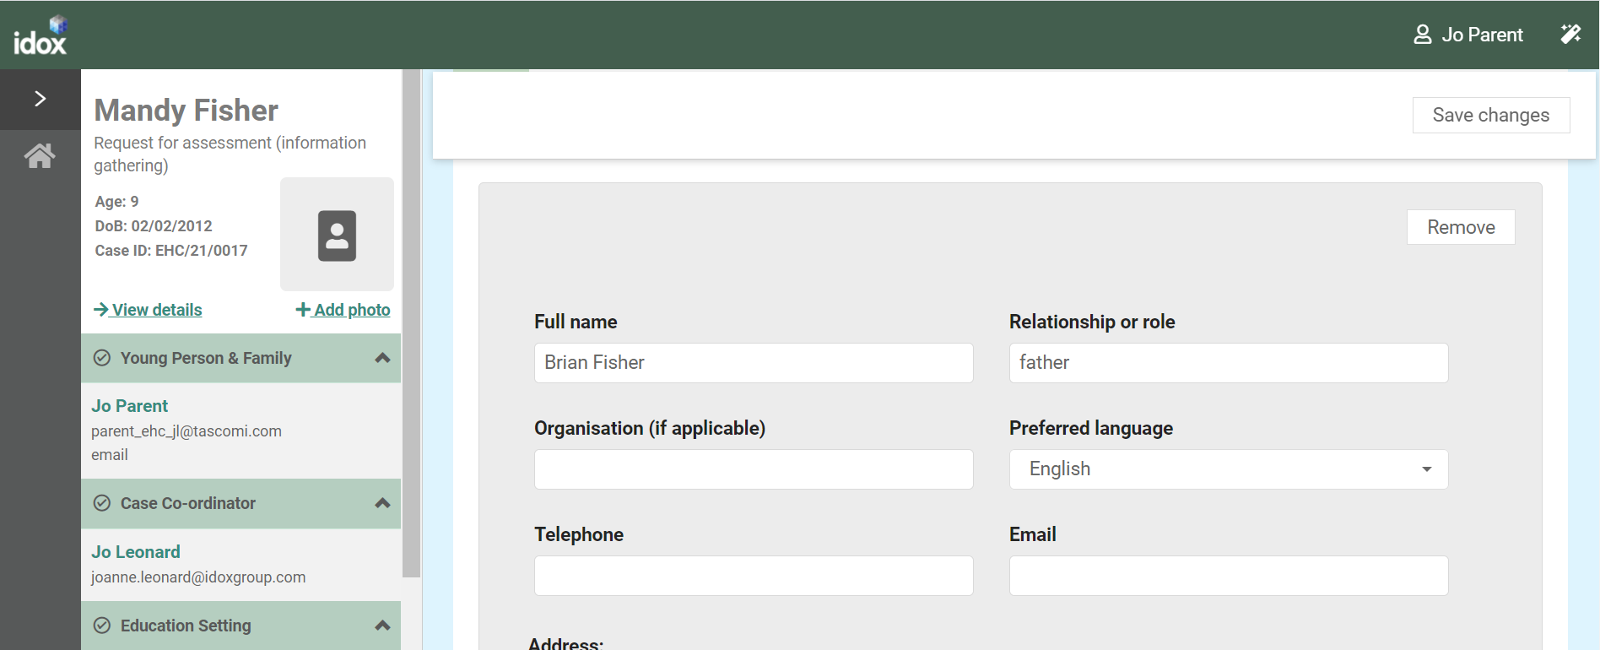

When you click on save, the information will update, and the following message will appear:

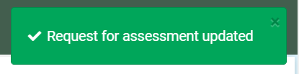

Once all of the information for the decision on the assessment has been gathered, a message will appear to say that the decision is pending:

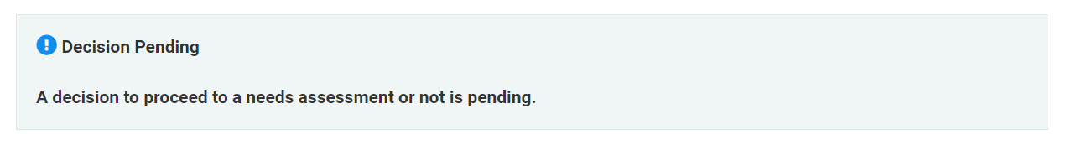

Once this message appears, it will not be possible to amend the request.

Sections of the Request

If any of the below details are incorrect, you will need to contact the case co-ordinator to get them updated.

**Details of the child or young person’s current education settings(s)**

**Details of person requesting an EHCP Assessment**

**Child or young person’s details**

The below details can be amended for yourself:

**Child or young person’s main contacts-** To add a further contact, click on Add. Complete the details as required and click on Save Changes.

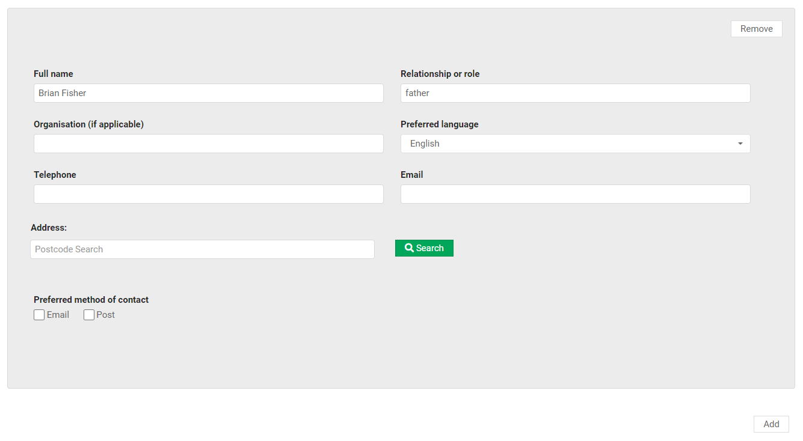

**Details of Previous Settings -** To add another education setting, click on Yes and the fields will appear allowing you to enter the details of the education setting.

**Important information about the child or young person -** Any information entered when the original request for assessment was made will be displayed here but can be amended or added to here.

**Supporting Documents -**If you want to add any relevant supporting documents, click on the Add Files button:

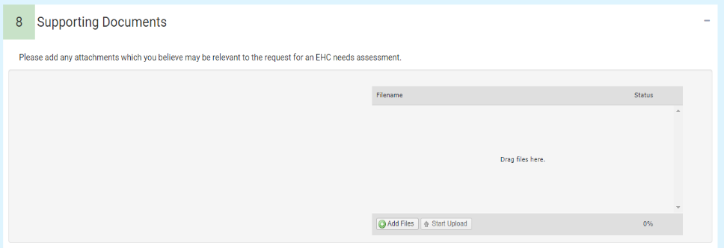

You will then need to navigate to the file wherever you have it saved on your PC.

Click on Open and the file will be uploaded. When uploaded file will be displayed as below:

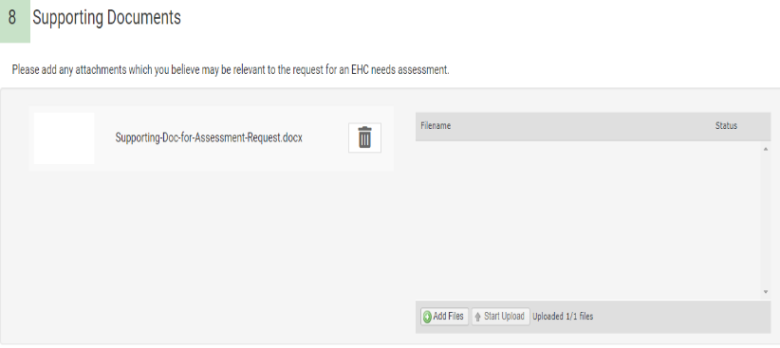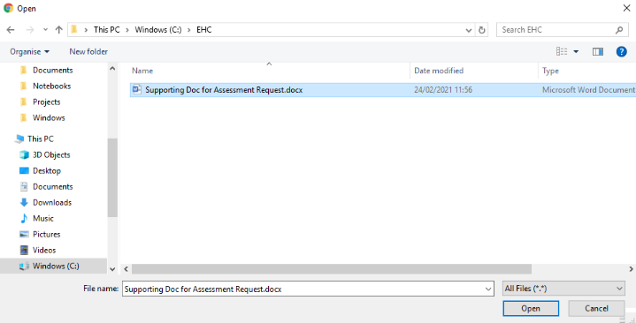

EHC Needs Assessment Decision

When the decision has been made as to if an EHC needs assessment for a child or young person will be carried out, you will receive an email telling you this and asking you to access the hub to view the details. The email will look something like this:

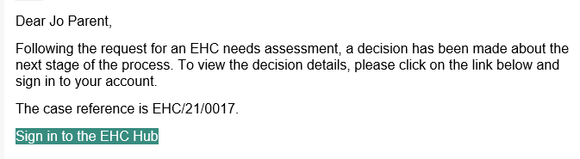

When you sign into the Hub, the welcome screen will look like this, with the status of the case shown below:

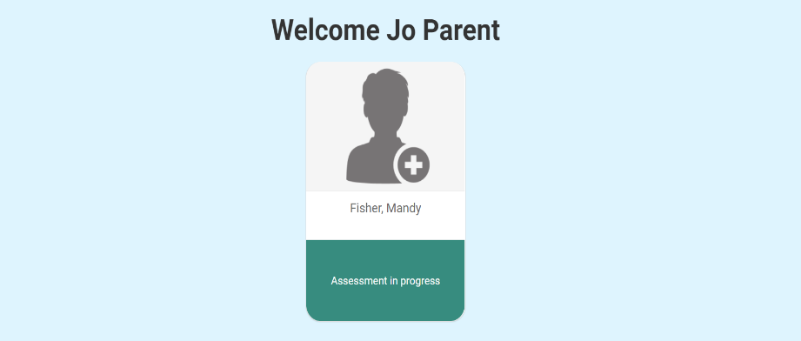

Or

If the decision has been taken not to proceed with an EHC Needs Assessment, the reason for the decision will be displayed here.

To view and download the letter with details about the decision, click on Download and click on the file in the bottom left-hand corner of the screen (the actual location of the downloaded document will be dependent on the web browser that you are using).

How to contribute to an assessment

If the decision has been taken to proceed with an EHC needs assessment, when you click on the Assessment, you will be provided with information about the EHC needs assessment process, including a link to a website that will provide more information about the different sections.

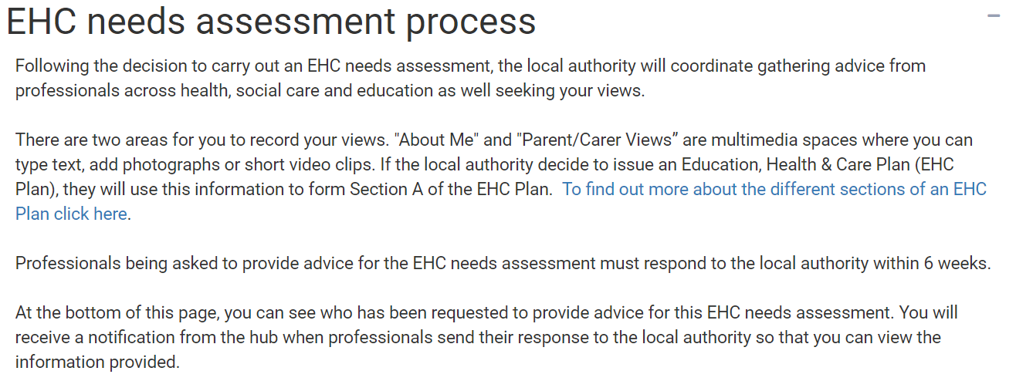

There are two sections for you to contribute to, they are **about** and **parent/carer views**.

About

The section is all about what is important to the child or young person. If it is possible, the information should be completed by the child or young person the assessment is for. If this child cannot complete it independently, and it is being filled in by someone else, it is important that this indicated in each section. If the local authority decides to issue an EHC Plan after the assessment is complete, content from these sections will be included.

There are 8 sections to be completed. Left click on each section to enter information:

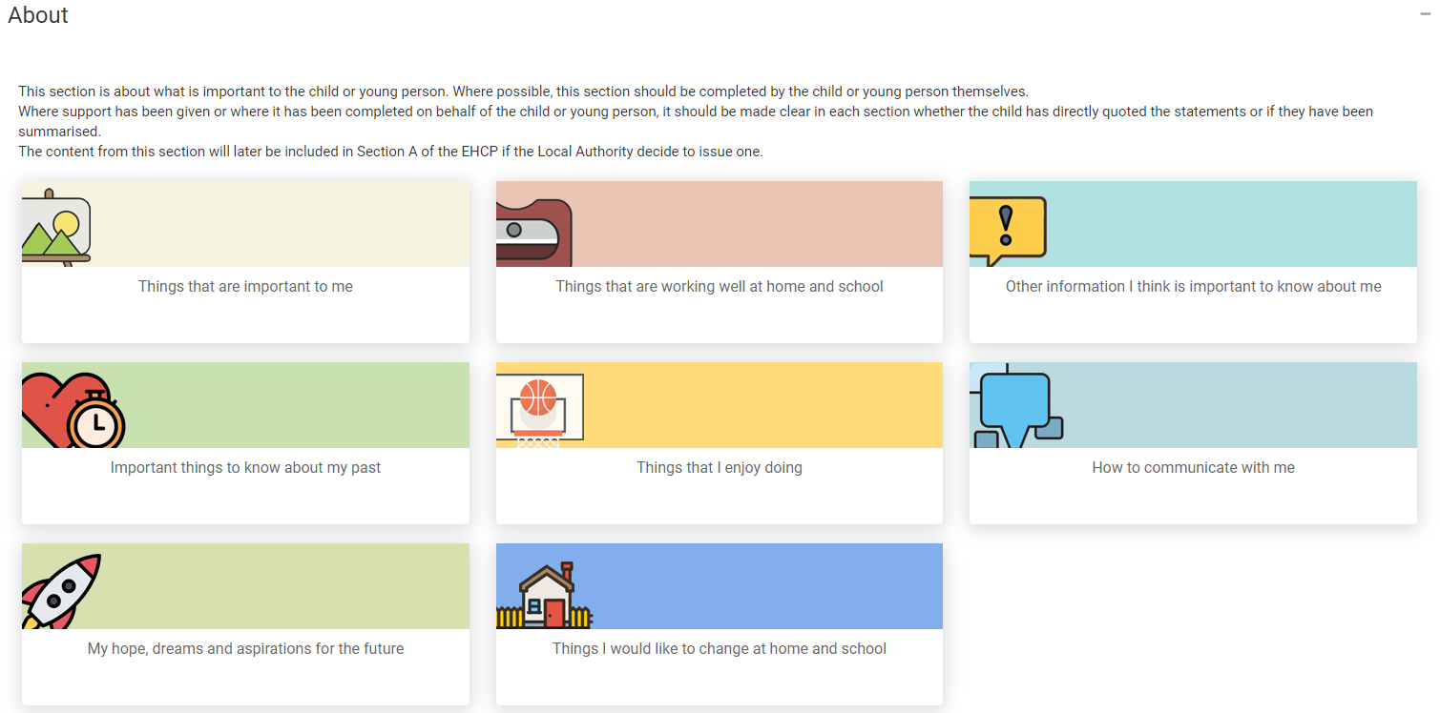

When you click on one of the options, a page will be displayed allowing information to be typed in:

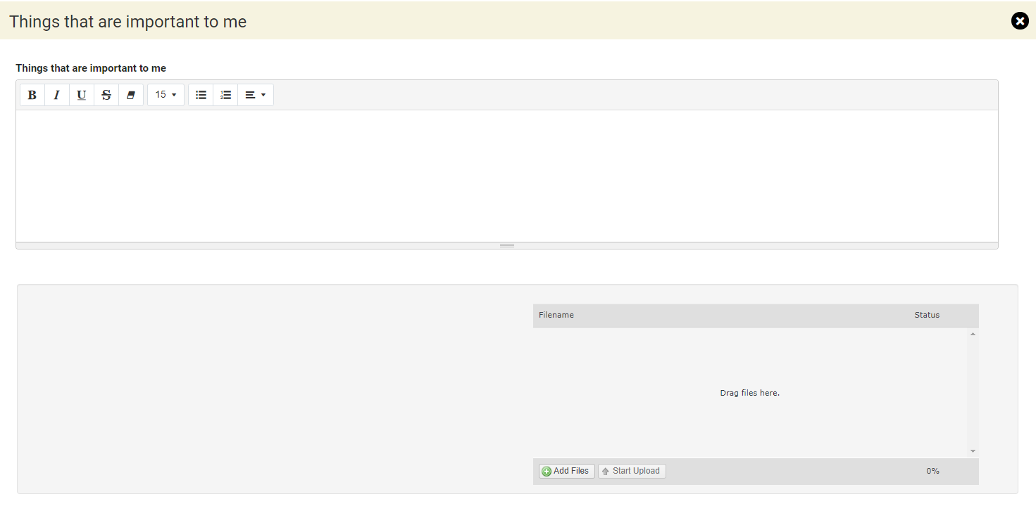

Click here for more information on using free text fields:

Underneath, there is also a section to add files if you wish. These could be files like documents, photos or short video clips. Click on the Add Files button and navigate to the file wherever you have it saved on your device:

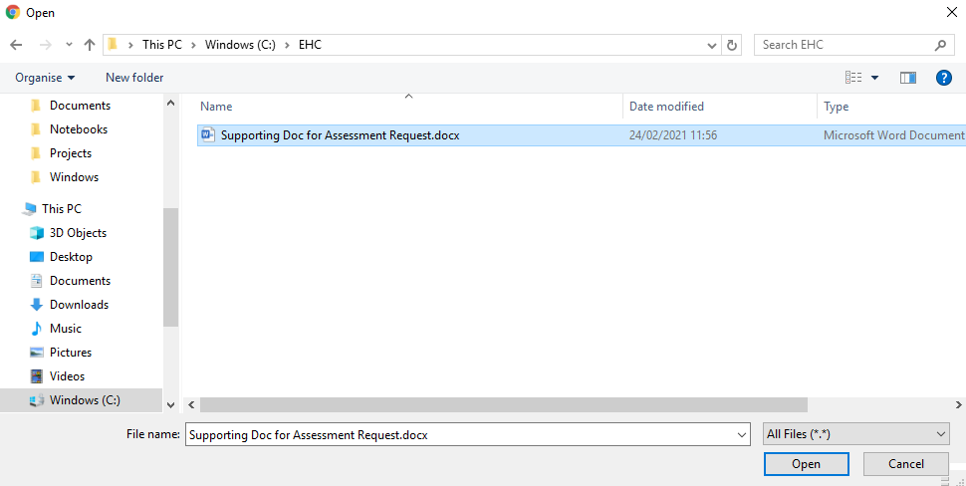

Click on Open and the file will be uploaded. The uploaded file will be displayed:

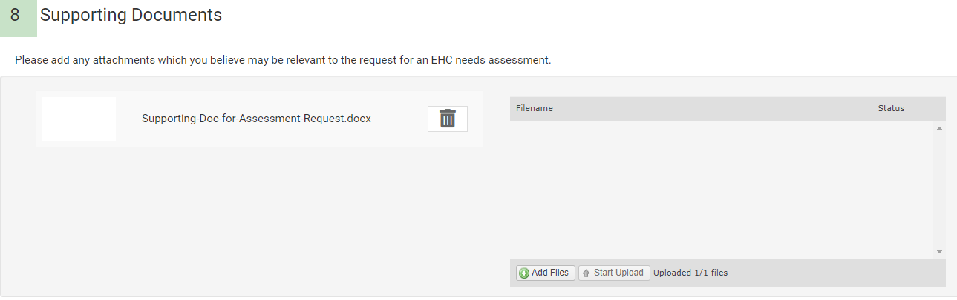

When you have completed the information, you need to save it before moving on to the next section. Click on Save Section to save the information:

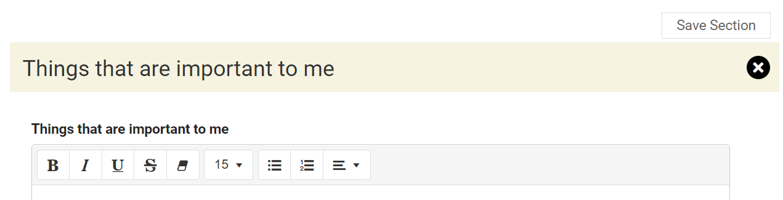

Once you have completed the information and saved it, you can access the next section. At the bottom of the section being completed, below the upload file area, there will be an arrow to the next section to be completed:

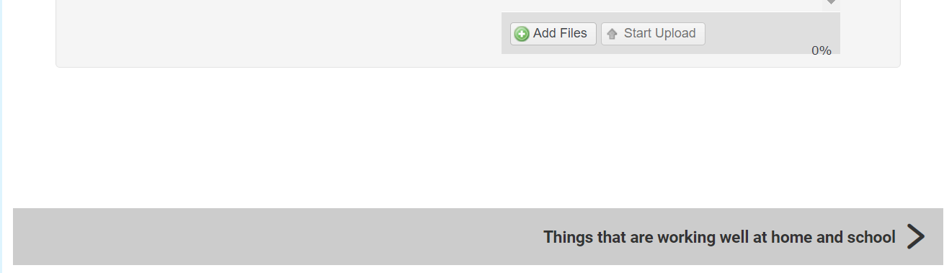

This will change depending on where you are in the record:

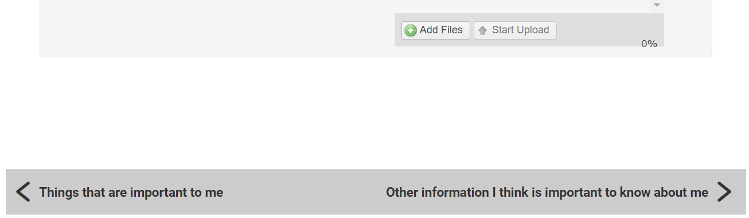

Alternatively, you can click on X and you will be taken back to the main page to choose which section you want to complete next:

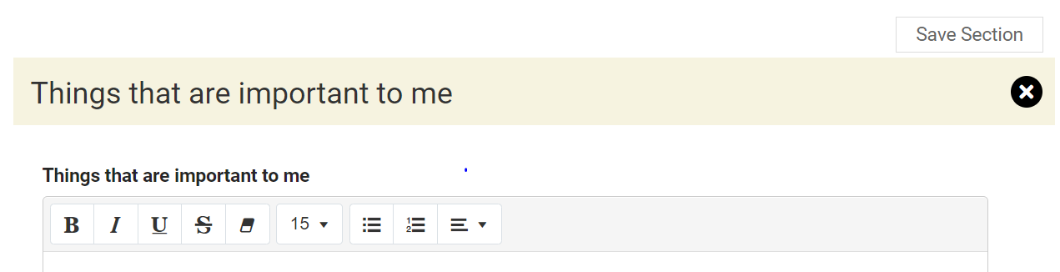

The sections to be completed are:

##### Things that are important to me

##### Things that are working well at home and school

##### Other information I think is important to know about me

##### Important things to know about my past

##### Things that I enjoy doing

##### How to communicate with me

##### My hopes, dreams and aspirations for the future

##### Things I would like to change at home and school

Parent Carer’s Views

This section is for the Parent or Carer of the child or young person to give their views:

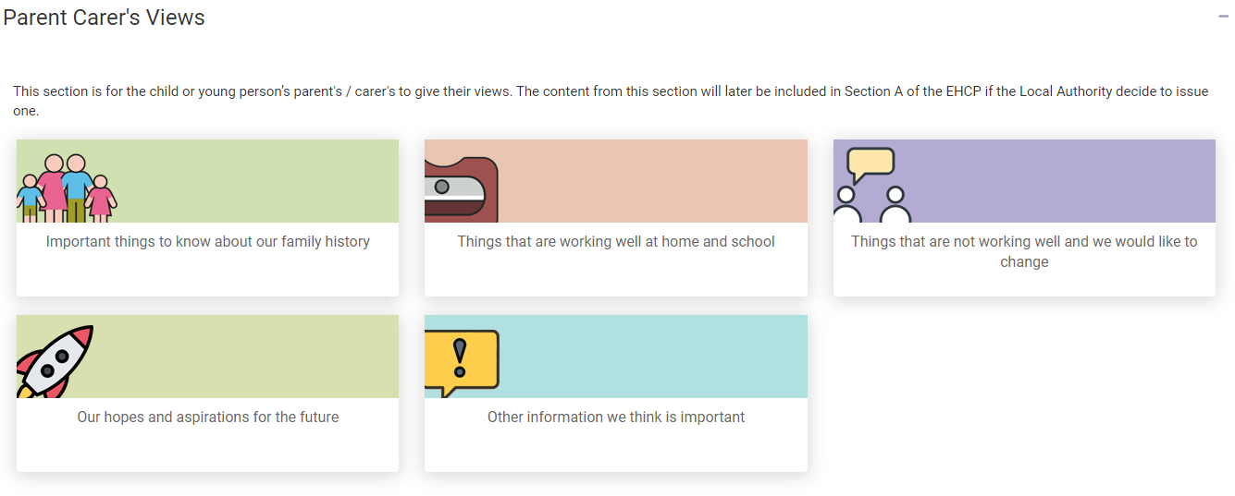

There are 5 sections to be completed.

When you click on one of the options, a page will be displayed allowing information to be typed in:

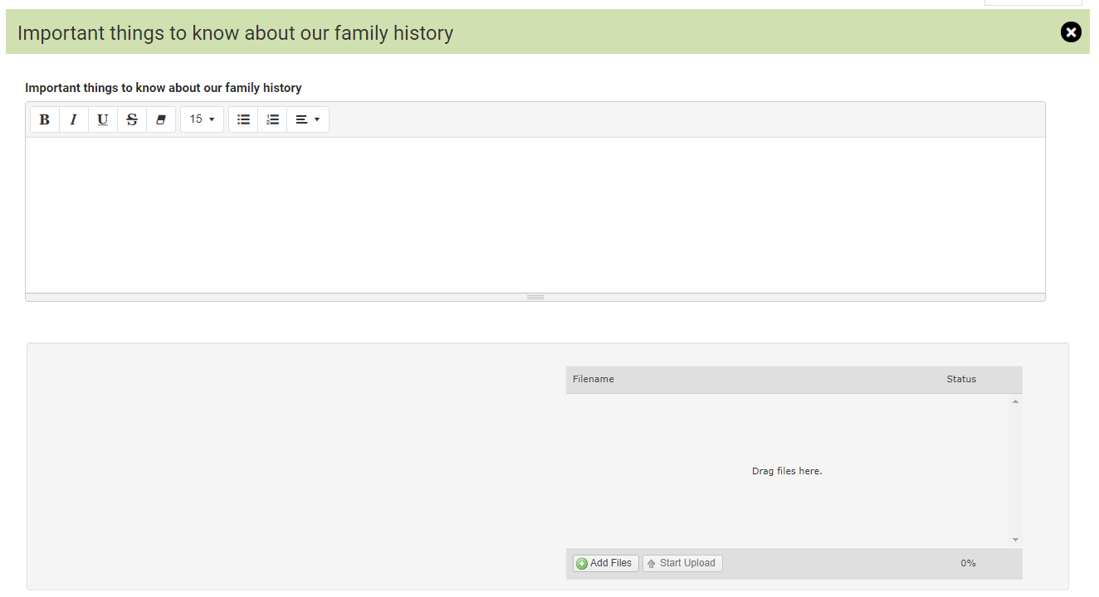

Click here for more information on using free text fields:

Underneath, there is also a section add files if you wish. These could be files like documents, photos or short video clips. Click on the Add Files button:

You will then need to navigate to the file wherever you have it saved on your Device:



Click on Open and the file will be uploaded. The uploaded file will be displayed:



When you have completed the information, you need to save it before moving on to the next section. Click on Save Section to save the information:

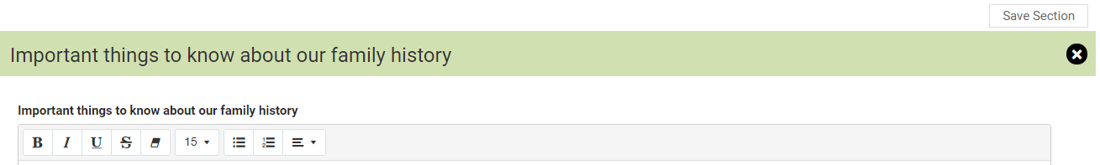

Once you have completed the information and saved it, you can access the next section. At the bottom of the section being completed, below the upload file area, there will be an arrow to the next section to be completed:



This will change depending on where you are in the record:

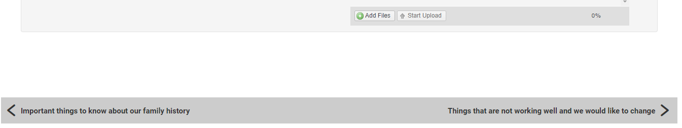

Alternatively, you can click on X and you will be taken back to the main page to choose which section you want to complete next:



The sections to be completed are:

##### Important things to know about our family history

##### Things that are working well at home and school

##### Things that are not working well and we would like to change

##### Our hopes and aspirations for the future

##### Other information we think is important

These are the two areas where you can contribute to the assessment.

Requests for advice

There is also a section showing who else has been asked to provide information for the assessment. When the professionals send their response to the Local Authority, you will get a notification email from the hub so that you can view the information provided:

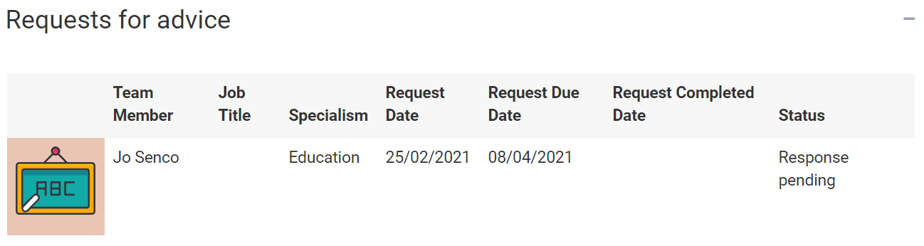

There are a number of people that might be asked to contribute to the assessment. These include:

##### Education professionals for education advice

##### Health Care professionals for medical advice

##### Education psychologists for psychological advice

##### Social Care advice

##### Any other person the local authority thinks are appropriate.

It is also possible for you to ask the case co-ordinator to request advice from a particular person if the Local Authority hasn’t done so already. A parent, carer, guardian or young person can ask the Local Authority to request advice from anyone working in education, health or social care as long as it is reasonable to do so. The case co-ordinator’s contact details are shown in the case sidebar.

Once the response to the request for advice has been received, the status will change to show this:

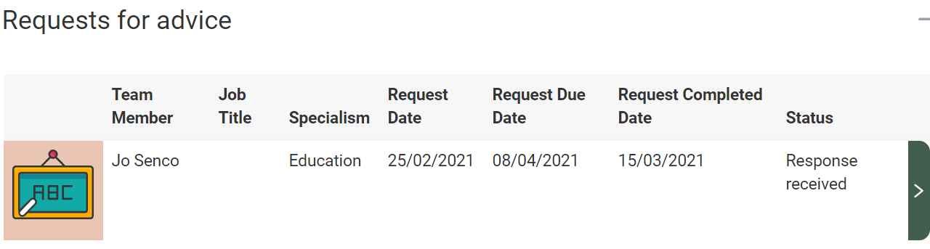

To view the response, click on the Green right pointing arrow and the Request for advice screen will be displayed, with the information entered by the person who the advice was requested from.

You can scroll up and down the screen to view the information entered, using the scroll bar on the right:

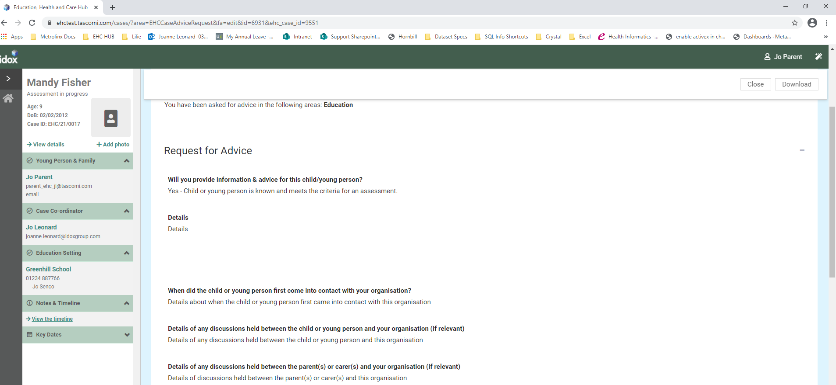

If further sections have been completed, they will be displayed with a green tick and a green arrow on the right:

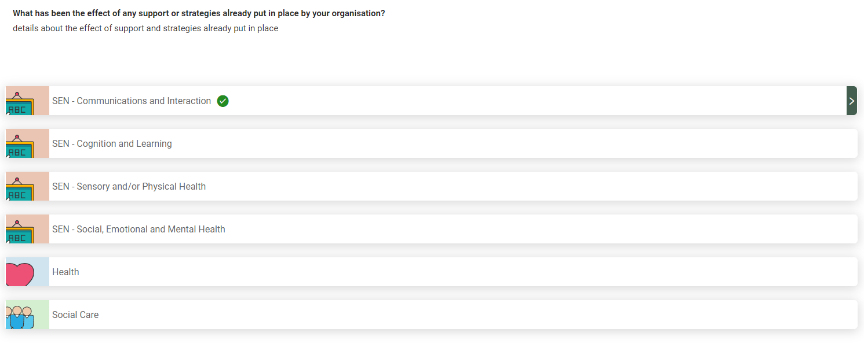

Click on the green arrow to view the information entered:

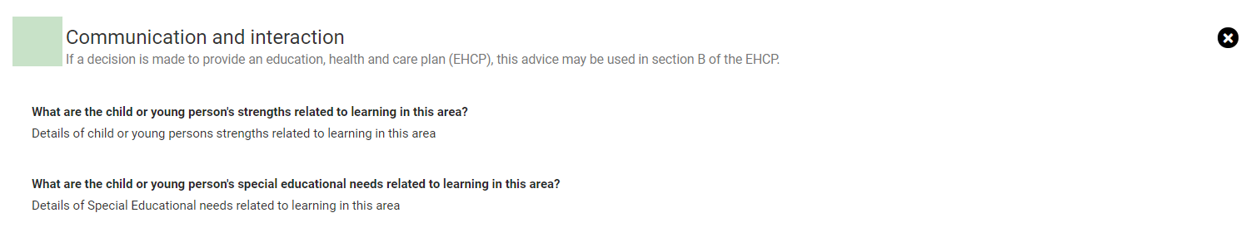

Click on the X to close the section and view another section. There is also a section displaying any documents that have been uploaded:

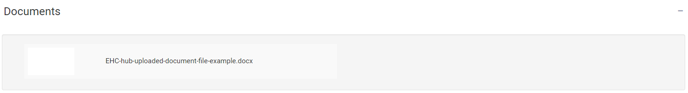

To view these documents, click on the white square and the document will show as a download in the bottom left-hand corner of the screen (the actual location of the downloaded document will be dependent on the web browser that you are using):

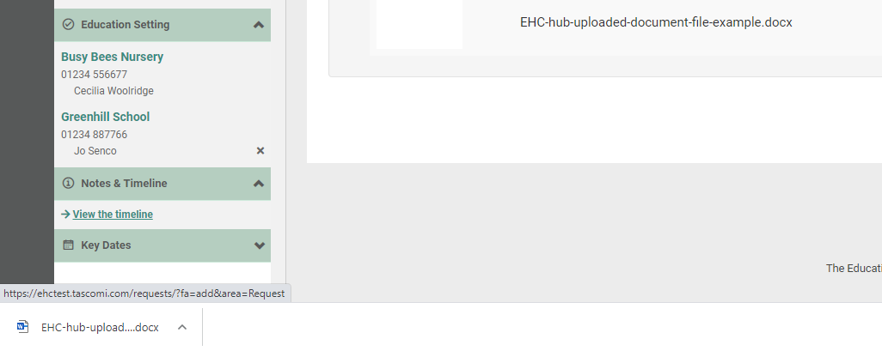

Left click on this to open it and view the information.

Once all of the information has been gathered together, the assessment can take place and the decision made about if an EHC Plan will be issued. A decision to issue a plan must be made within 16 weeks of the case start date. To view important dates, click on Key Dates at the bottom of the menu bar on the left:

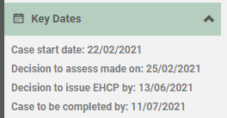

The case start date is the date the request for an EHC needs assessment was made. The dates will show when something happened or when it is due to happen.

When the decision has been made to issue a plan or not, you will receive an email telling you that there is new information on the Hub for you to view.

The email will look something like this:

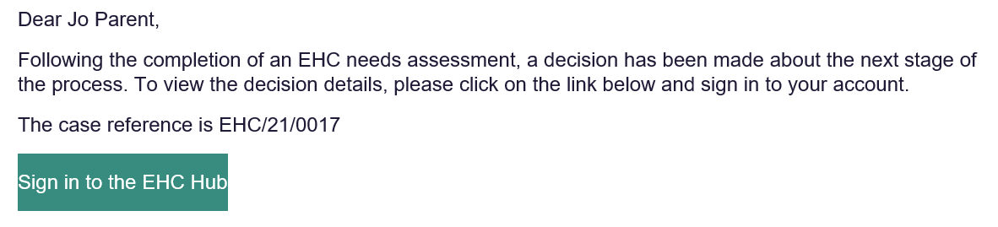

You will need to sign into the Hub to view the result of the decision.

If a decision has been made to issue an EHC Plan, a draft plan will be published as soon as possible. You will be asked to comment on this draft plan within 15 calendar days and when these comments have been submitted, the draft plan can be updated before a final plan is issued.

When you log in to the Hub, the status will show like this:

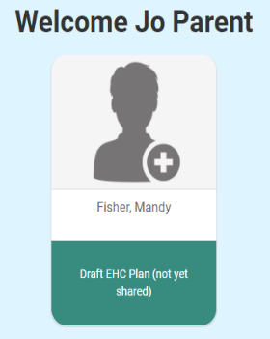

Or

If the decision has been made to not issue an EHC Plan, the following information will be displayed:

This will include the reason for the decision and a letter that can be downloaded with more information about the decision.

To **view this letter**, click on Download.

If the decision has been made to issue a plan, the status will show that a decision has been made to proceed to a plan:



To view details and download the letter about the decision, click on Decision:

The information below will be displayed:

For more information about the decision, click on Download to download the letter.

Click on Plan. The main screen will show some information about the next part of the process:

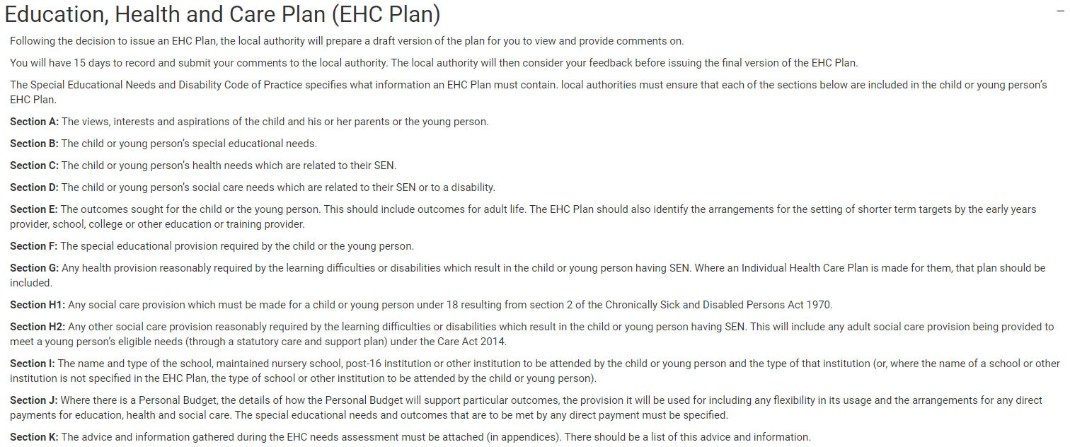

This details what information the plan must contain.

Underneath, it will show if the plan has been drafted yet. If it is still being drafted, this will be displayed:



If you haven’t already read the advice contributions that might go into the plan, click on Assessment at the top of the screen to view the Assessment page:

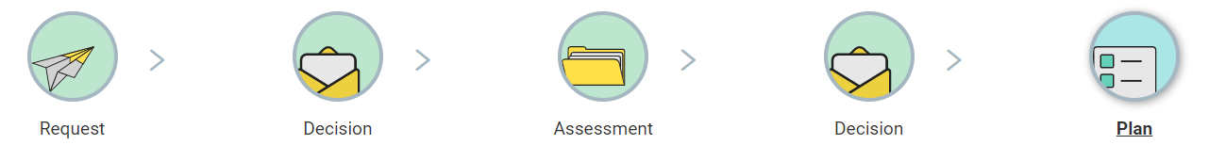

At the bottom of this screen there is the Requests for Advice section:

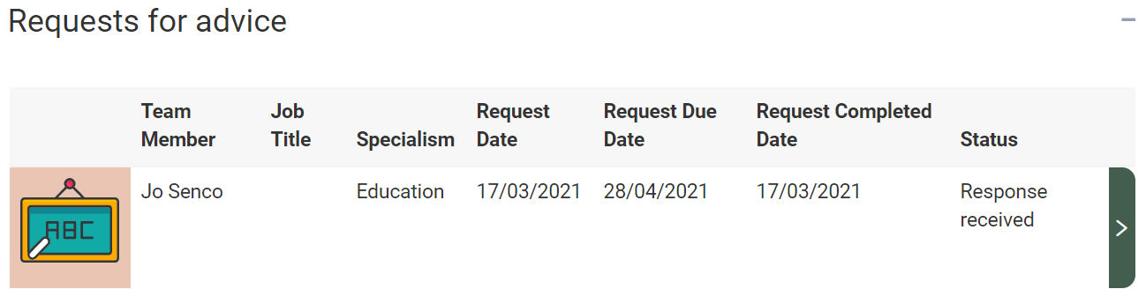

See here for more information on Requests for Advice.

How to Comment on a Draft Plan

When the draft plan is ready, it will be shared. When it has been shared, you will receive an email to say that it is available to view:

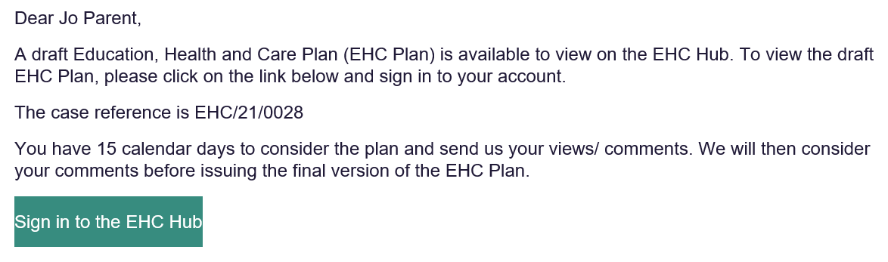

The draft plan will show the advice that has been submitted by any of the professionals who were asked for advice as well as the planned outcomes and provisions.

If the draft plan is ready to be viewed, the screen underneath the information section will look like this, showing when the Draft was shared:

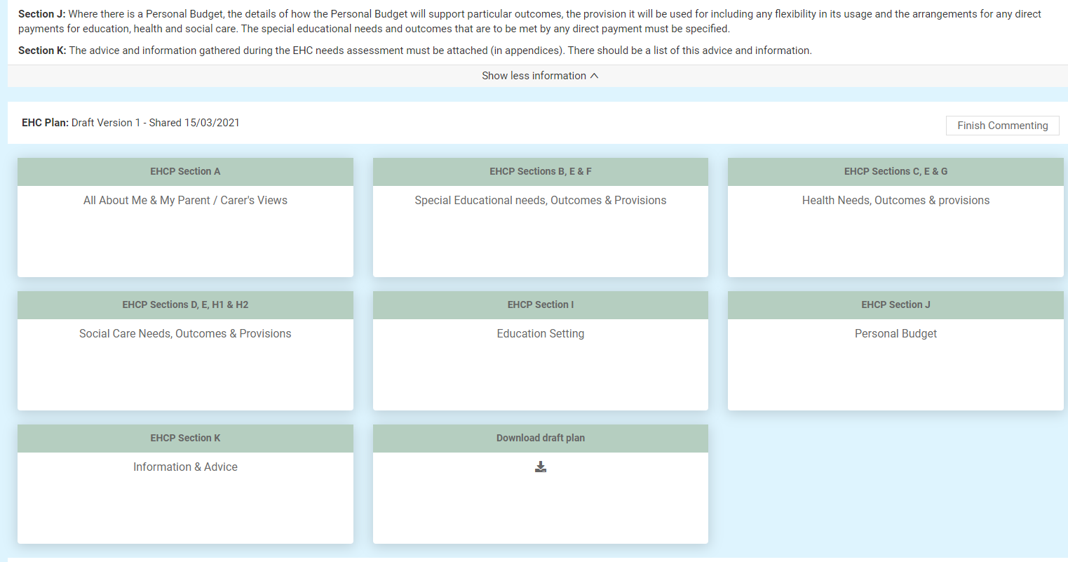

Each of the sections make up part of the Plan. To view more information on each section, left click on that section.

You will be able to comment on the whole section, any parts of the section and any outcomes or provisions in that section.

Each section may have multiple parts to it.

When you click on an EHCP section, the different parts of that section will be displayed with a brown heading:

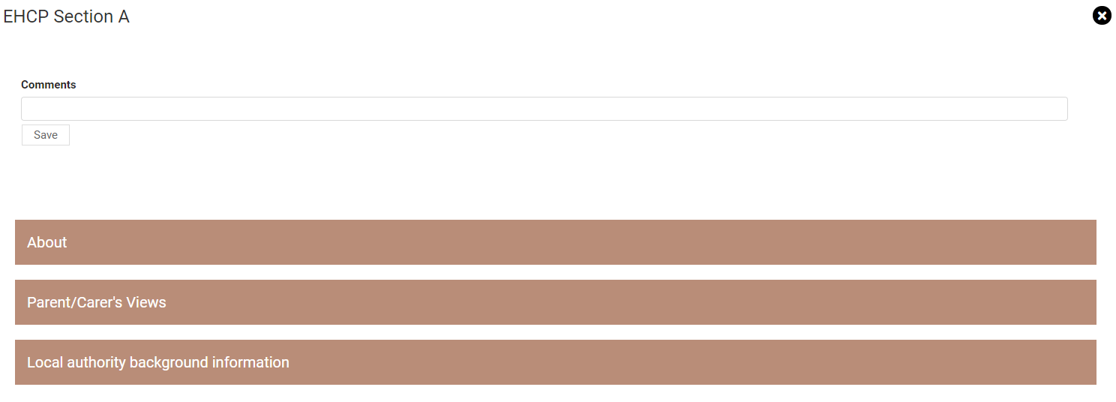

Left click on each of the part headings to view any information that has been entered

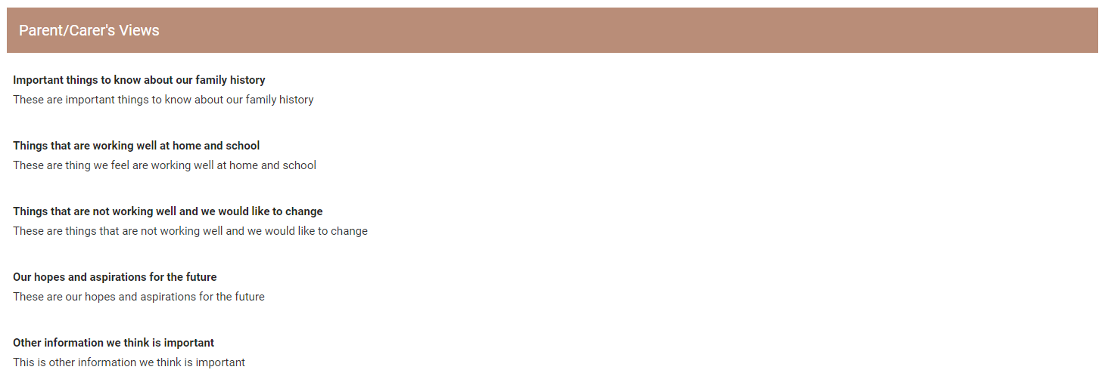

If a section is not applicable (for example, the child or young person does not have extra Health Needs) it will look like this:

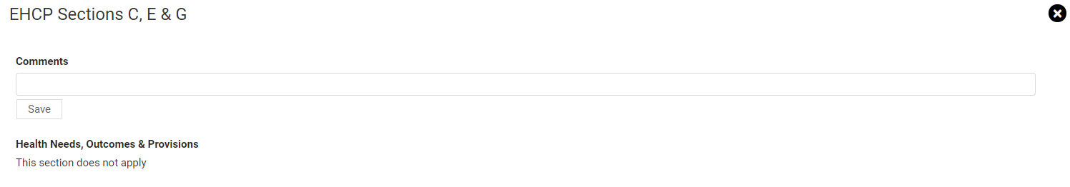

(It is still possible to add a comment to this section if required.)

It is important to scroll up and down the screen to make sure you can see all the information that has been added to the plan. Left click on the scroll bar on the right-hand side of the screen to move up and down on the screen.

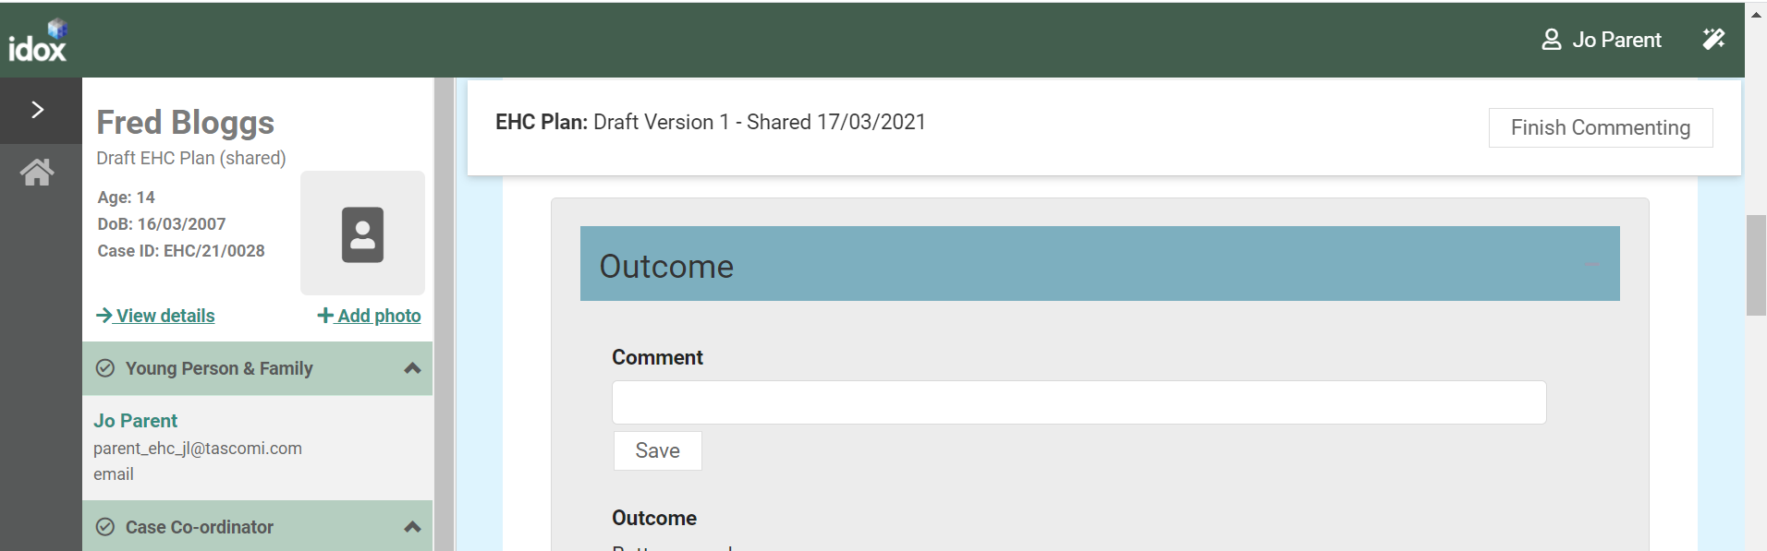

Click on the X to return to the main screen:

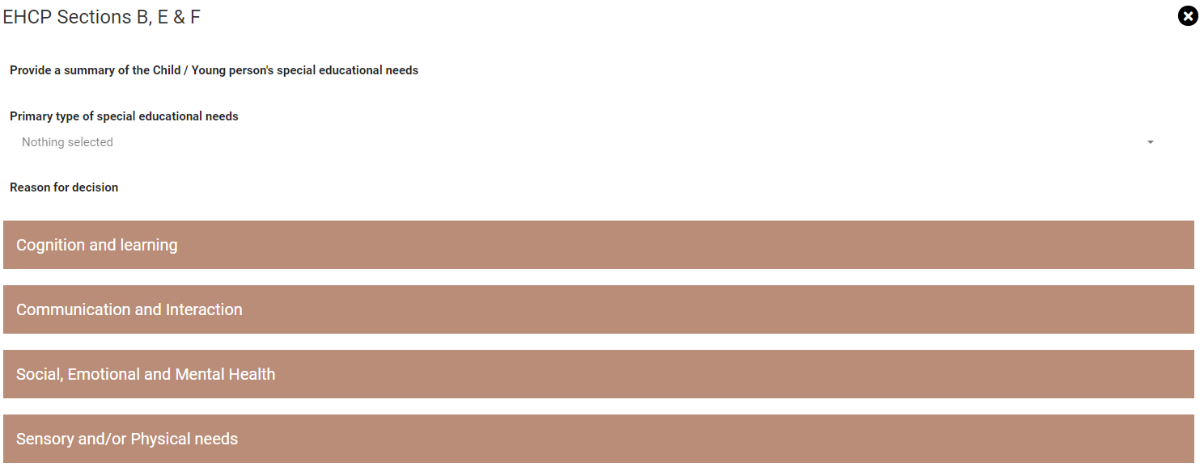

Adding a comment to a Section

To add a comment to any section, by left clicking on that section

Each section will have a comments box for you to enter your comments on the information in the plan:

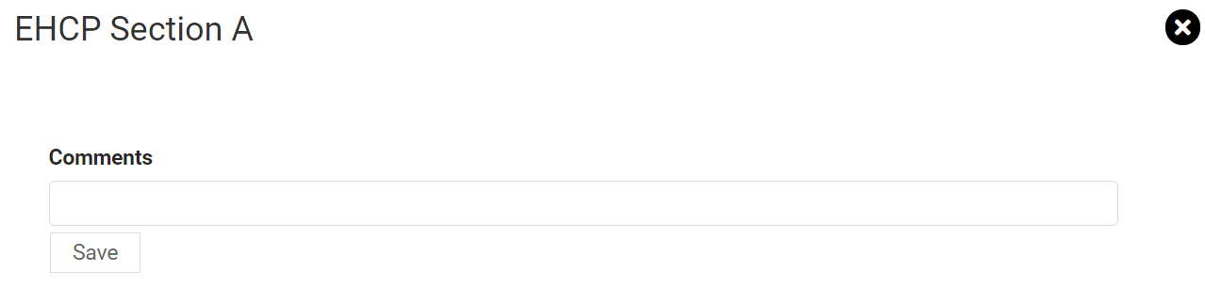

When you have entered your comment, click on Save to save the comment. This will be a draft, and no one will see them until you click on Finish Commenting to submit your comments. You can type as much information as required in this field.

Then click on the X to return to the main screen.



You will then be able to view the information. When you have finished looking at this information, click on close:

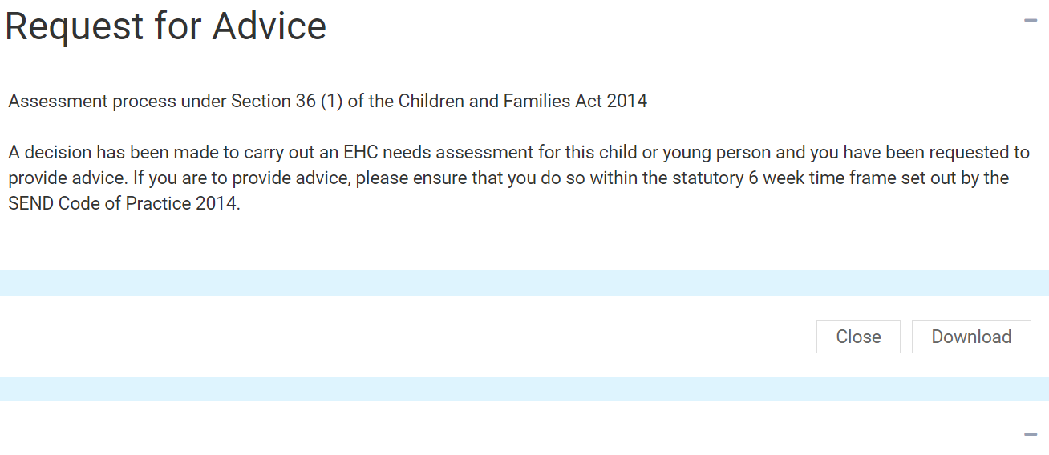

Left click on Plan at the top of the screen to return to the draft plan:

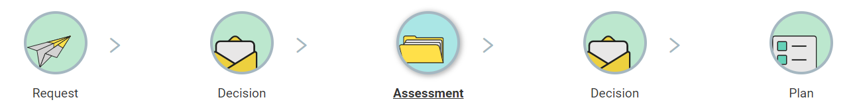

How to finish commenting on a draft plan

When you have added all your comments and you are ready to submit them, click on Finish Commenting:



Any comments you add will not be visible to other people until you click on Finish Commenting. At that point they will be added to the plan and other people with access to the case will be able to read them. Even if you have no comments, this will tell the Case Coordinator that you have finished looking at the document and have no comment to make.

Downloading a Draft Plan

If you wish to download the draft plan as a PDF file. Click on Download Draft Plan:

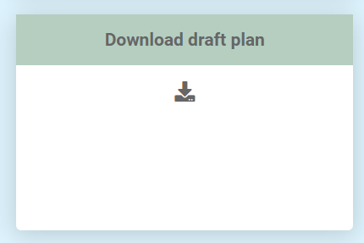

The downloaded plan will then show in the bottom left-hand corner of the screen. Left click on this to view the contents of the PDF file. This can be saved to your own device, if required.

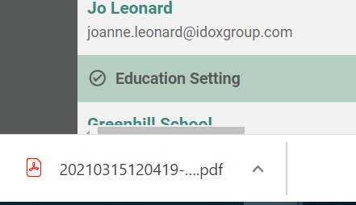

EHC Plan Consultations

At the bottom of the plan, there will be list of the Parent/Guardians/Carers or young people that have been consulted about this draft plan, as well as Education Settings consultations:

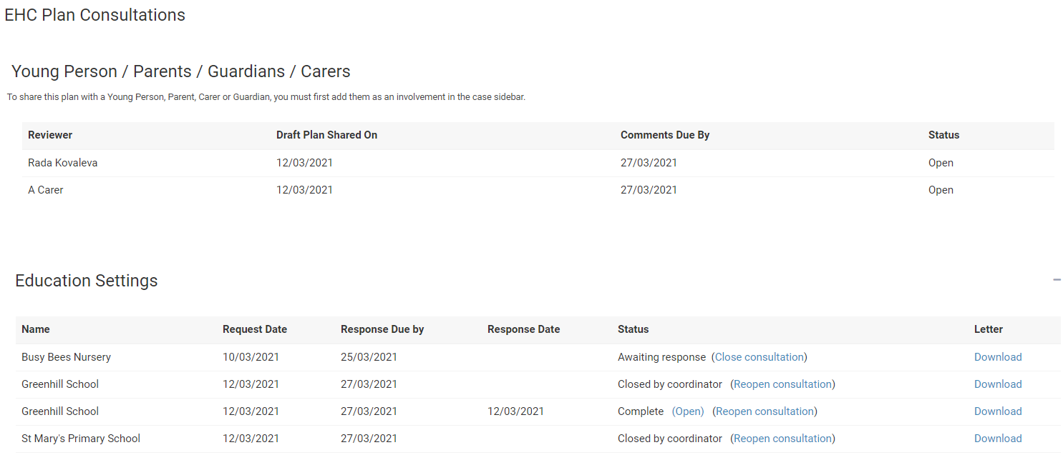

It will also have the status of the comments process. If this says Open, then that person is still in the process of adding comments.

Once you have clicked on Finish Commenting the status will change to show Completed:



Under the educational settings, it will show all educational settings that have been consulted and the status of that consultation.

To view the letter the educational setting was sent as part of the consultation, click on Download in the letter column:

The downloaded letter will then show in the bottom left-hand corner of the screen:



Left click on this to view the contents of the PDF file. This can be saved to your own device, if required.

EHC Plan Review

Once a plan has been finalised, it must be reviewed annually. Information about the review date will be displayed when you log into the Hub and view the case.

You will receive an email with the details of the review meeting when it has been arranged. This is usually done by the SENCo within the education setting.

In the meantime, when you log in, the case status will be displayed like this:

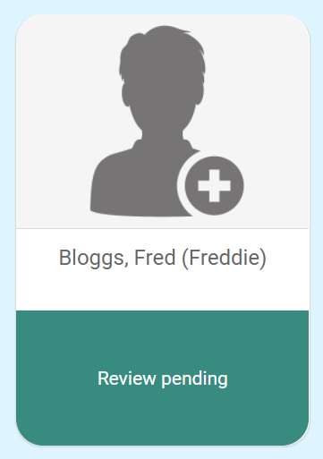

When you click on this, you will be taken to the EHC Case Summary page:

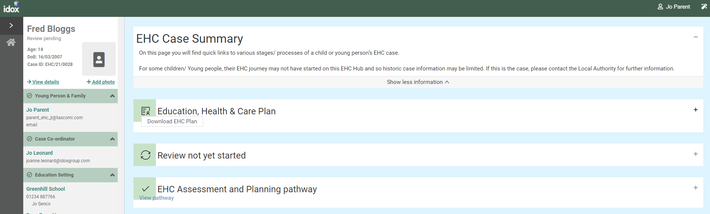

EHC Case Summary Page

This includes sections of information for the history of activity on the EHC Hub.

Education, Health and Care Plan

Click on the Plus to open this section:

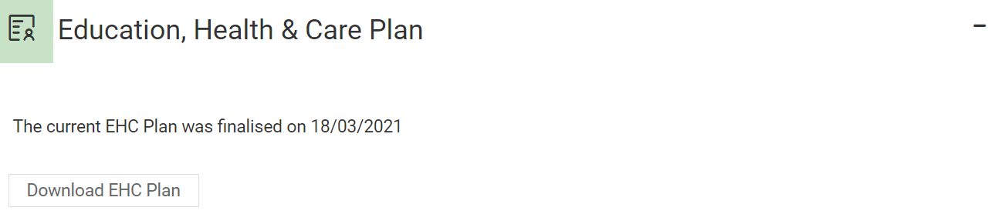

This will display when the current plan was finalised. You can also download a copy of the plan if required by clicking on the Download EHC Plan button. The download will appear in the bottom left-hand corner of the screen:

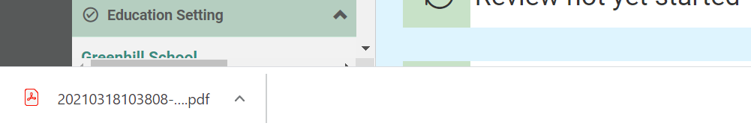

Review not yet started

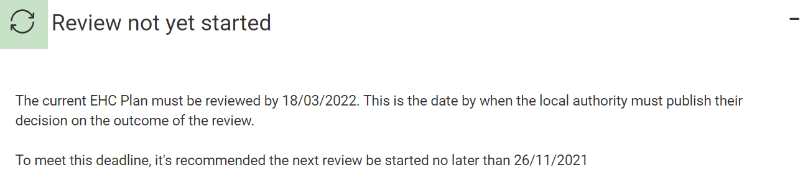

This will tell you when the plan is due to be reviewed.

EHC Assessment and Planning Pathway

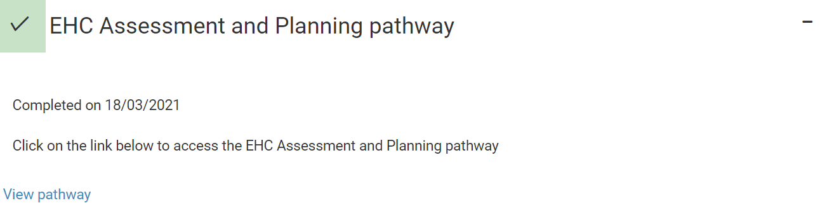

This will tell when the assessment and planning pathway was completed. To view the pathway, click on View Pathway.

This will take you to the pathway page where you can view the information entered previously on the pathway to the Plan:

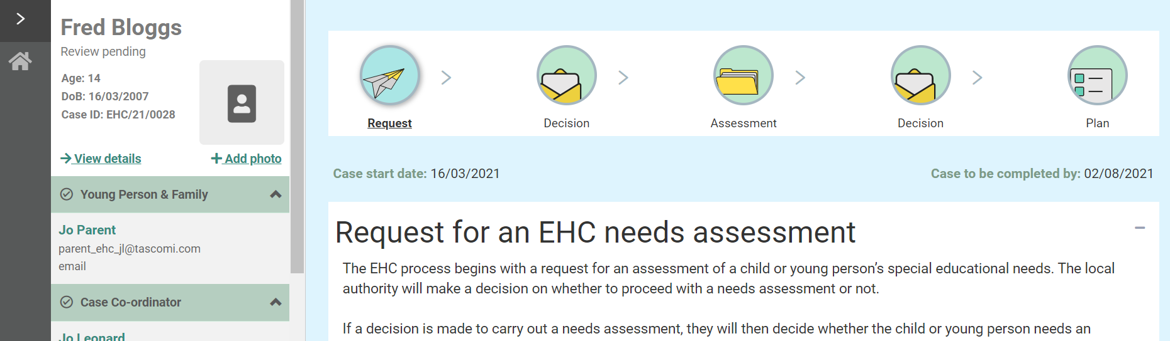

Click on any of the status buttons at the top of the screen to view the information.

EHC Plan Review Meeting

When the review meeting has been arranged, you will receive an email with the details of the date, time and venue for the meeting:

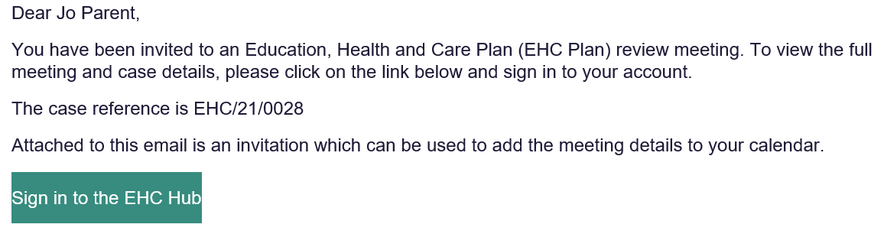

When you have your email, and sign into the HUB, the main screen will look like this:

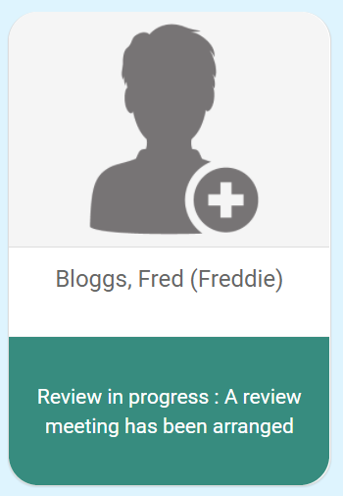

When you click on this, you should be taken to the current stage of the annual review pathway. Should this not be the case, to view the details of the meeting, click on View the case summary on the left-hand side

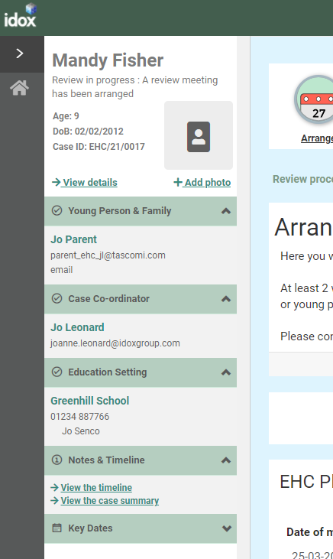

In the Review in progress section, click on Open review at the current stage.

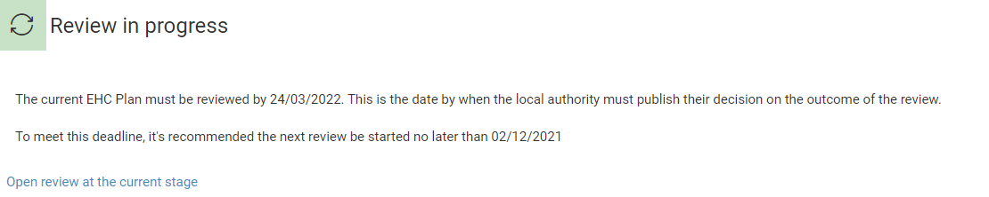

Details of the meeting will be displayed:

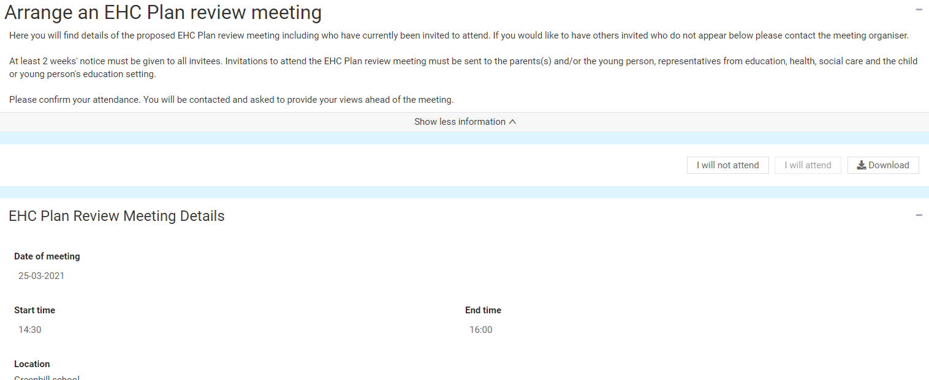

EHC Plan Review Meeting Details

This will show the date, time and location of the meeting:

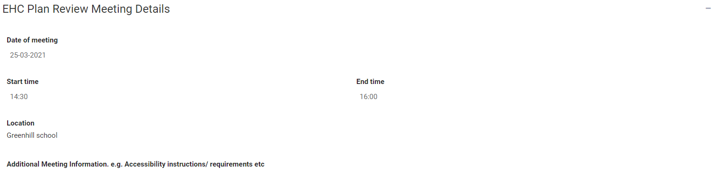

People Invited to the Meeting

This will show all the people who have been invited to the meeting and if they have confirmed if they will attend or not:

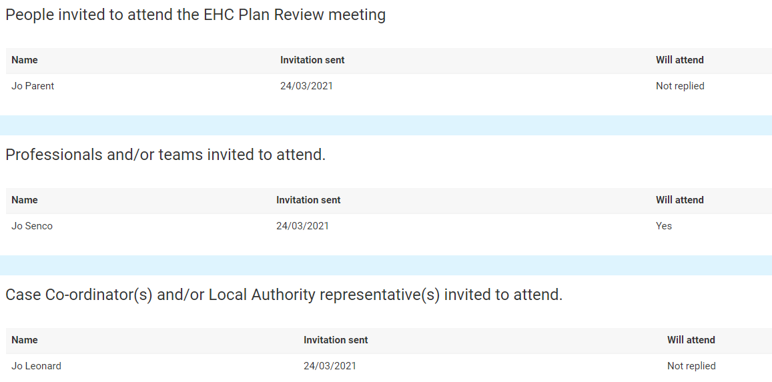

You will need to confirm if you will or will not be attending the meeting. To do this, click on the ‘arrange’ icon at the top of the screen.



At the top of the screen, there will be two buttons:

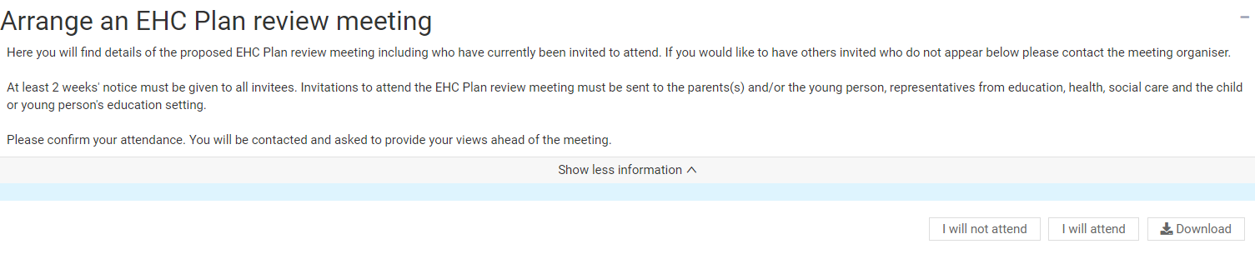

Click on the button to indicate if you will or will not attend the meeting.

Views on the Plans Progress and Outcomes

As part of the review, there will be a consultation as to if it is felt that progress is being made towards the outcomes set out in the Plan. Both you and the child or young person can put your views on this.

The Childs or Young Persons Views

The first section will be the views of the child or young person:

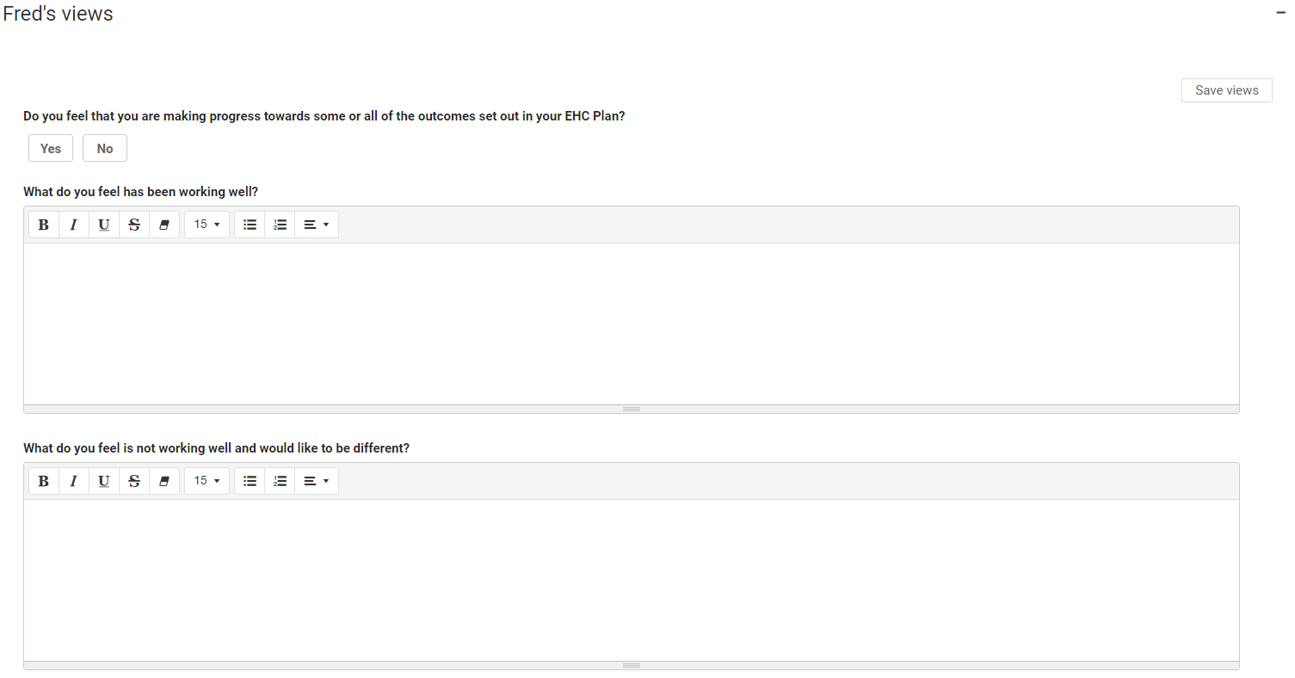

Click on the Yes or No button to indicate if you feel that progress is being made towards the outcomes in the EHC Plan.

To enter more information about what is and isn’t working well, left click anywhere in the boxes. Click here for more information on using free text fields.

When you have entered your views, click on Save Views.

Any information previously entered during the assessment process can be viewed below this:

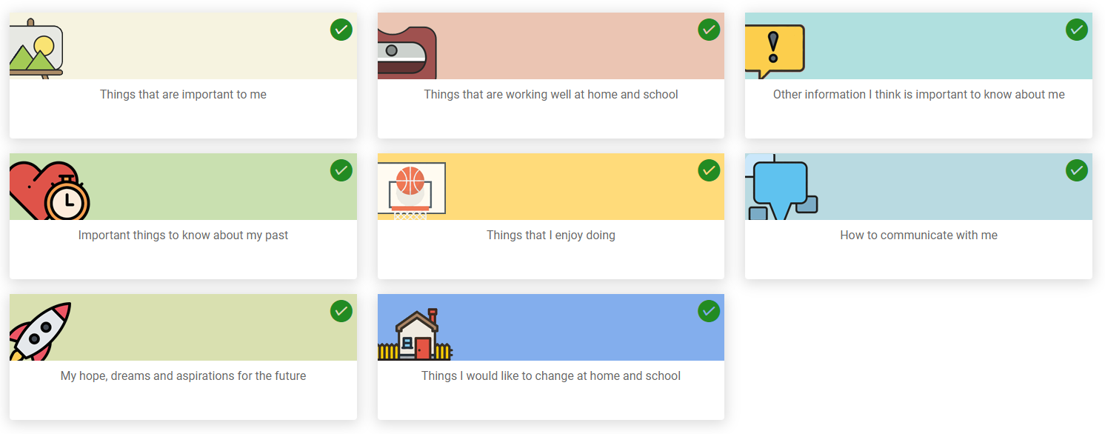

A green tick in the top right-hand corner of the section means information has previously been entered this section. To view that information, click on the tile and it will be displayed:

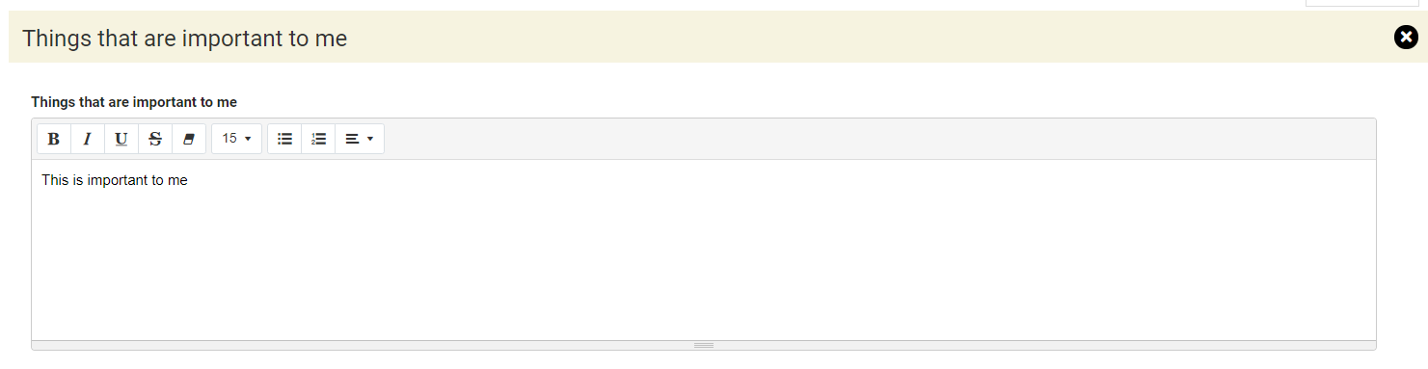

The Parent or Carer’s Views

The second section is for the Parent/Carer’s views:

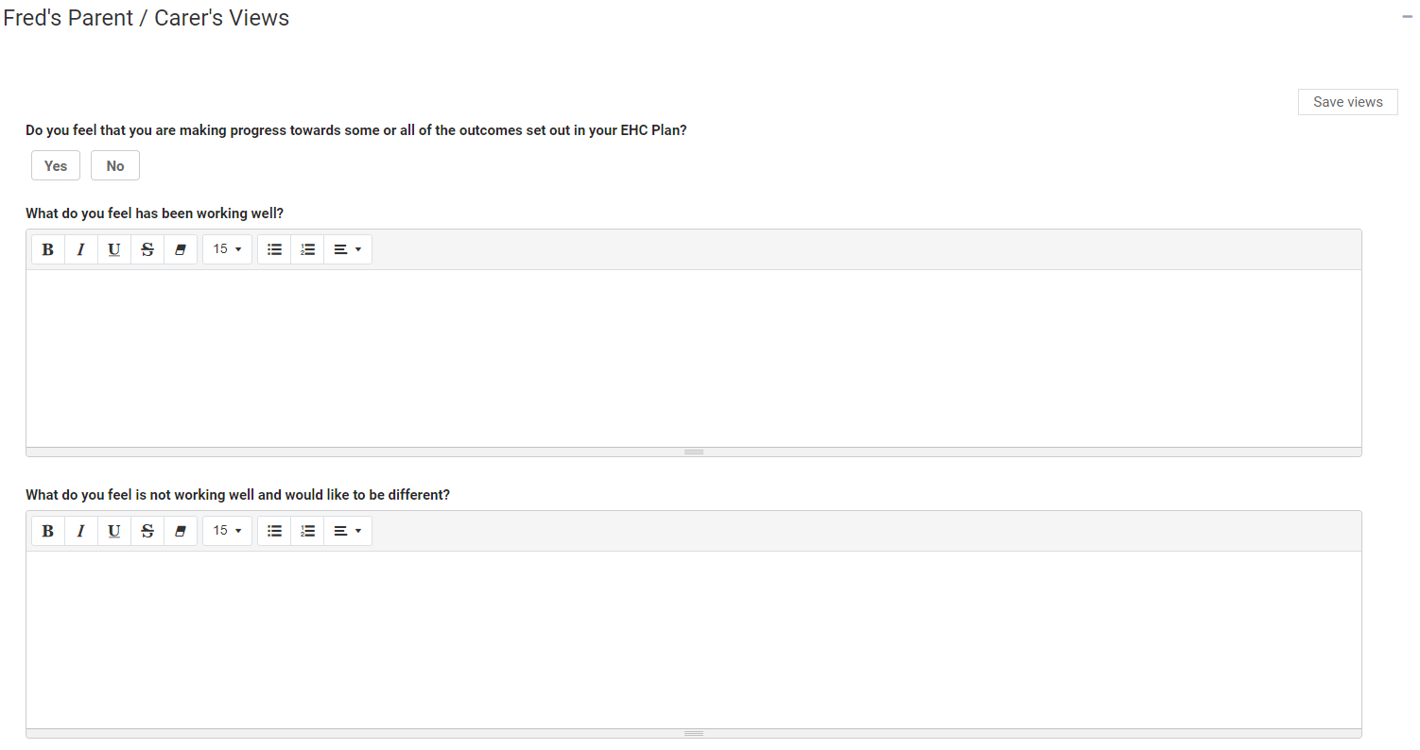

Click on the Yes or No button to indicate if you feel that progress is being made towards the outcomes in the EHC Plan.

To enter more information about what is and isn’t working well, left click anywhere in the boxes and start typing any information you want to enter here. Click here for more information on using free text fields:

When you have entered your views, click on Save Views.

Any information previously entered during the assessment process can be viewed below this:

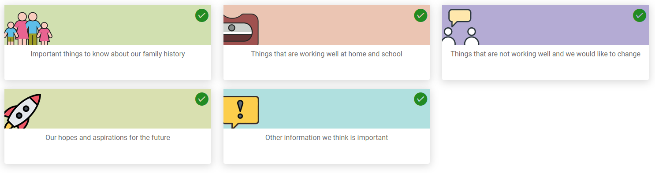

A green tick in the top right-hand corner of the section means information has previously been entered this section. To view that information, click on the tile and it will be displayed:

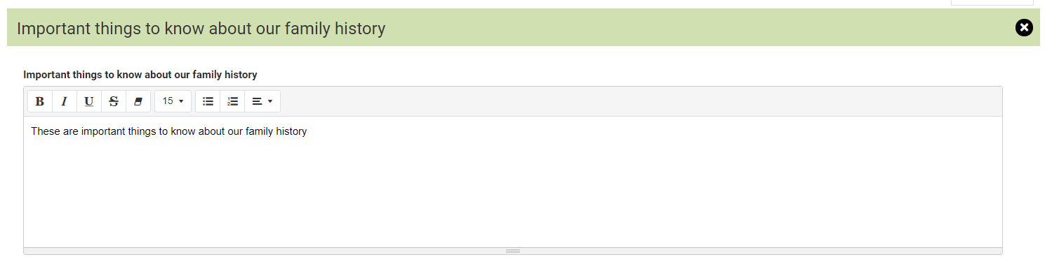

Requests for Information

At the bottom of the page, there is a section showing who else has been asked to provide their views on the progress towards outcomes of the EHC Care Plan:

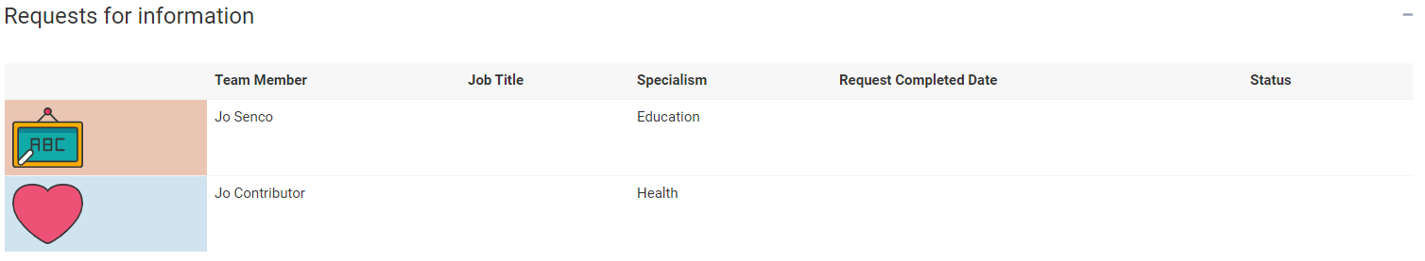

Once the response to the request for information has been received, the status will change to show this:

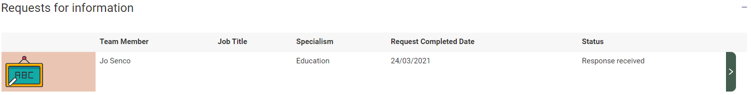

To view the response, click on the Green right pointing arrow and the Request for information screen will be displayed, with the information entered by the person it was requested from.

Where an advice area has been commented on, they will be displayed with a green tick and a green arrow on the right:

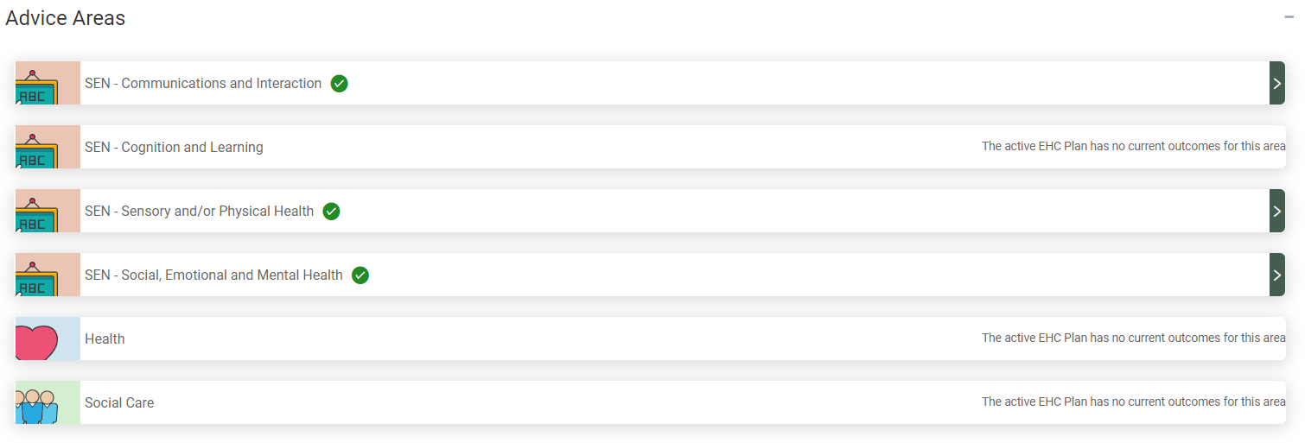

Click on the green arrow and scroll down to view the information entered. Comments will have been made as to if any changes are needed to the outcome or any additional short-term targets needed, as well any changed needed to the Special educational needs provision:

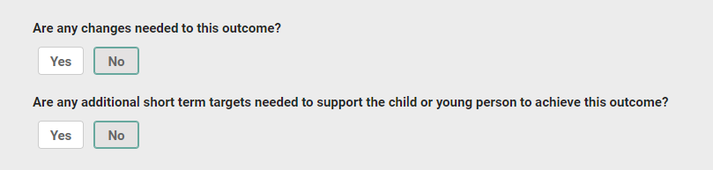

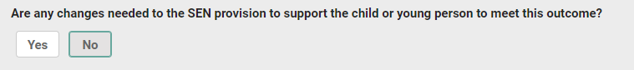

Click on the X to close the section and view another section:



There is also a section displaying any documents that have been uploaded:



To view these documents, click on the white square and the document will show as a download in the bottom left-hand corner of the screen:



Left click on this to open it and view the information.

EHC Plan Review Meeting Details

This will show the date, time and location of the meeting:



People Invited to the Meeting

This will show all the people who have been invited to the meeting and if they have confirmed if they will attend or not:



EHC Plan Review Meeting

When the meeting has taken place, a record will be created of who was invited, who attended and when the meeting took place. The details of the discussions held at the meeting and any recommendations made will be displayed in the next section, the Report on the review.

When the meeting record has been created, when you log into the Hub, the status will look like this:

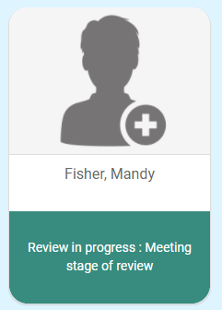

When you click on this, the status will be displayed like this:



This has 5 sections

EHC Plan Review Meeting Details

This will show the date, start time and end time and Location of the meeting.

Record of people who were invited and attended

This will show who was invited and if they attended.

Other Attendees

This will show a list of people who were not originally invited to attend ahead of the meeting, but were in attendance

Additional Meeting Information

This will show any specific information about the meeting, like if apologies had been received or new information was brought to the meeting.

The details of the actual plan review discussion will be shown in the review report in the next section.

Meeting Documents

Any supporting documents from the EHC review meeting will be attached here and can be viewed.

EHC Plan Review Meeting: Draft Report

When the report on the plan review meeting is being compiled, when you log into the Hub it will look like this:

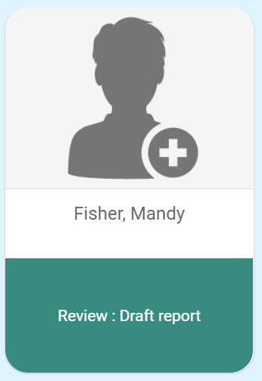

When you view the case, a message will be displayed to say that it is being drafted:

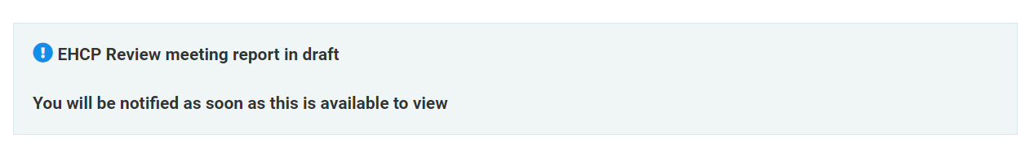

When the report is complete, it will be submitted to the local authority to consider the information provided and decide on whether the current EHC Plan needs to be amended, ceased or maintained.

If you log into the hub, during this time, the status will look like this:

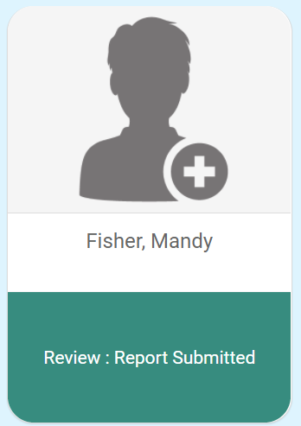

When you view the case, there will be a message to say this:

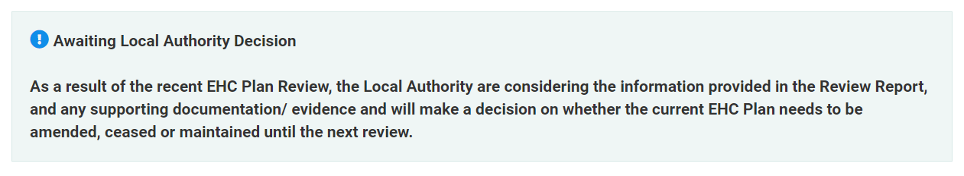

When the decision has been made about the next stage of the process, you will receive an email telling you the decision has been made and asking you to sign into the hub. This should be within four weeks of the meeting taking place:

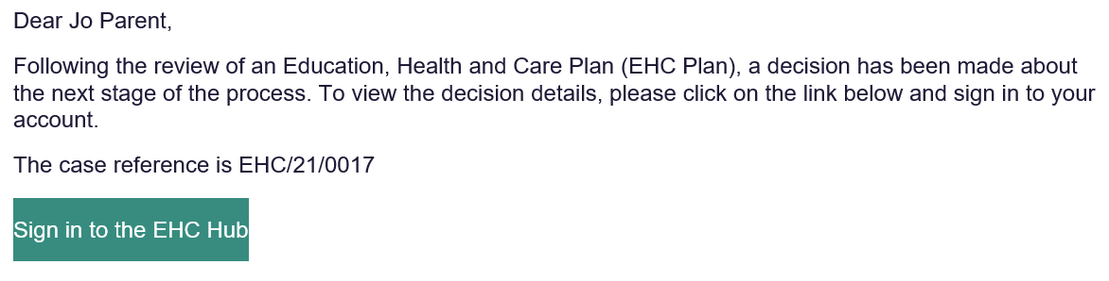

EHC Plan Review Meeting Report

When you log into the hub and click on the case file, the EHC Case Summary Page will be displayed. The contents of the page displayed will vary dependent on the outcome of the review.

Viewing the EHC Plan Review Meeting Report

Under the Completed reviews section, click on view pathway:

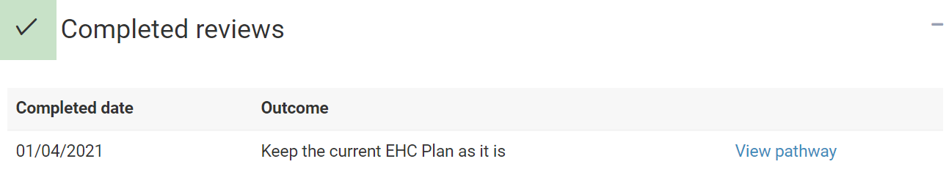

To view the Report, click on Report at the top of the screen:

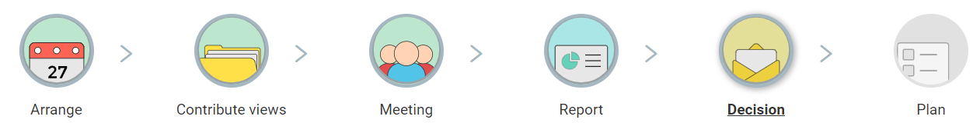

The following screen will appear:

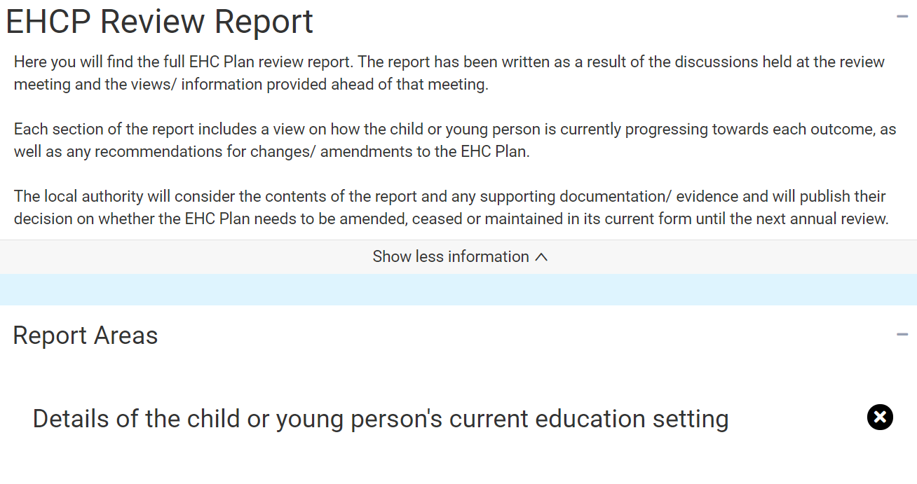

At the top of the screen will be information about the report.

Below that are listed the Report Areas:

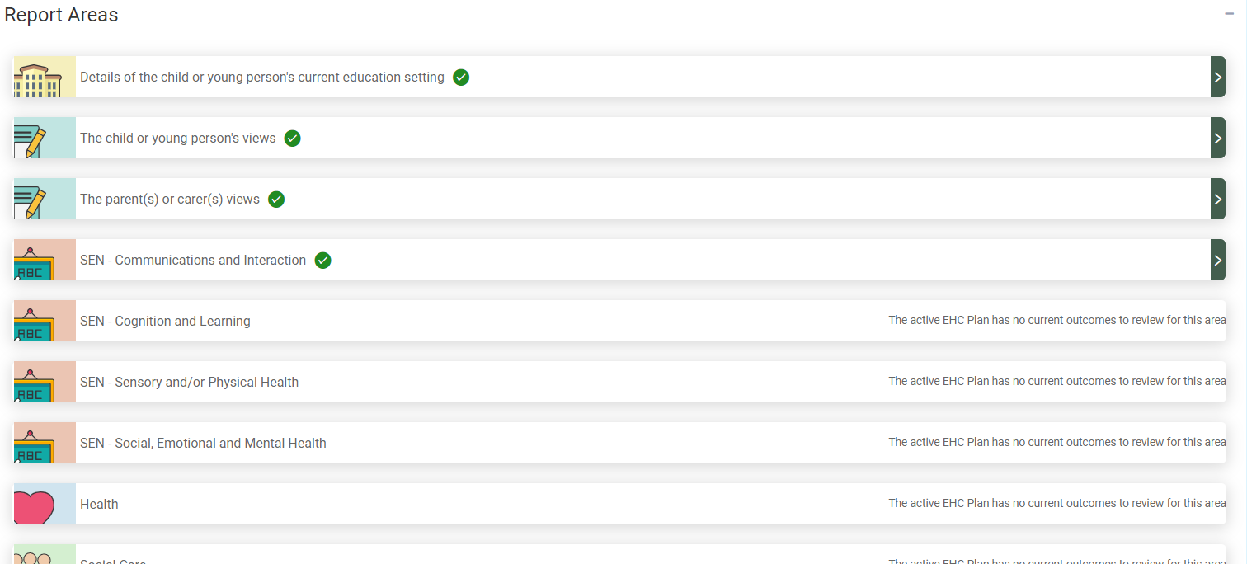

To view the details of that area, click on the Green arrow on the right. The section will then be shown in more detail:

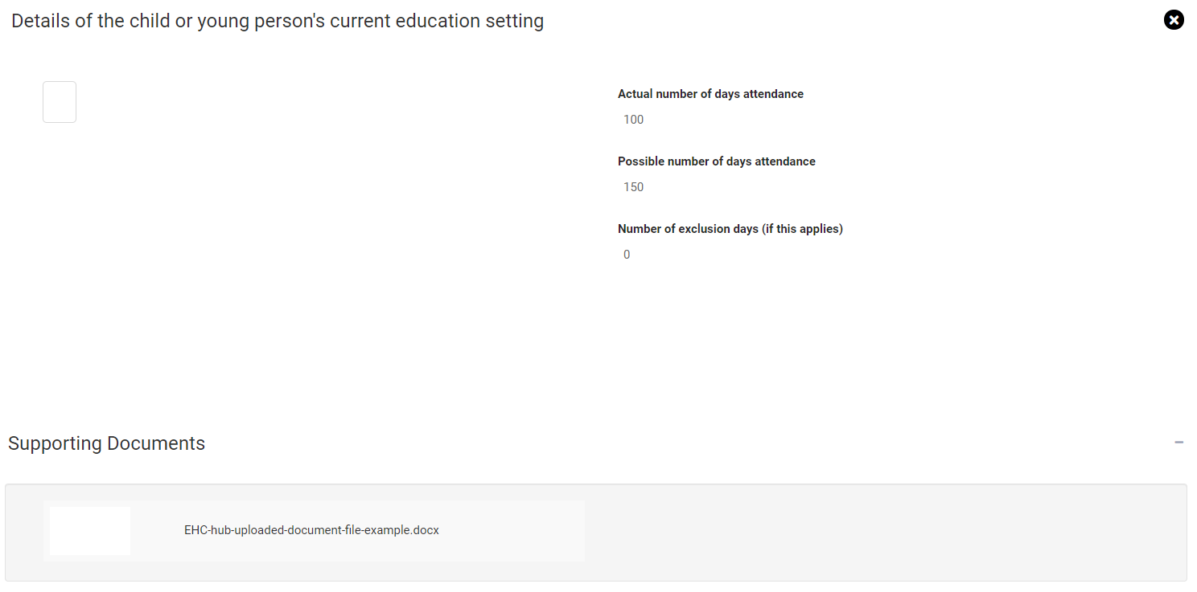

Click on the X to close that section and view another section.

Outcome of a Review

Once the review has taken place, there are three potential outcomes.

1. The Local Authority decides to make no changes to the plan and must be reviewed again within 12 months. Click here for more information on the review pathway.
2. The Local Authority decides to amend the plan based on recommendations in the review. Click here for more information on the plan
3. The Local Authority decides to cease to maintain the plan. The plan will be removed based on recommendations in the review. If the plan is ceased to be maintained, you will still be able to access all of the historical information on the EHC Hub.

**Contact Us**

Should you need any help and support please contact your educational setting, ICDS Case Worker

**Bassetlaw and Newark & Sherwood areas:** [icdsehcBandNSlocality@nottscc.gov.uk](mailto:icdsehcBandNSlocality@nottscc.gov.uk)

**Mansfield and Ashfield areas:** [icdsehcMandAlocality@nottscc.gov.uk](mailto:icdsehcMandAlocality@nottscc.gov.uk)

**Broxtowe, Gedling and Rushcliffe areas:** [icdsehcBGRlocality@nottscc.gov.uk](mailto:icdsehcBGRlocality@nottscc.gov.uk)

**Post 16 Team:** [icdsehcpost16@nottscc.gov.uk](mailto:icdsehcpost16@nottscc.gov.uk)

**Annual Review Service Organiser:** [serviceorganiser.annualreview@nottscc.gov.uk](mailto:serviceorganiser.annualreview@nottscc.gov.uk)