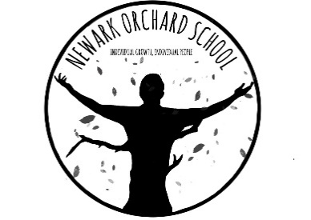

“Thank you to all staff and learners from Newark Orchard for being awesome. What stood out for me the positive qualities of the staffs interaction with the learners and the fantastic attitudes and outlook your students have. A real pleasure working alongside you to support and encourage your outstanding young people.” – Lee, NCS instructor

Employer encounter feedback 2021!

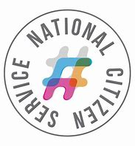

I thought the experience went really well from my part, I had more than enough information to work with to prepare what was needed for our conversation. I was and am more than happy to share my experiences, good and bad about my job role. I hope that your student didn't find it too overwhelming I felt on my part I threw a lot of information at her and it might have been a lot to take in all at once, so I would be more than happy in the future to help her out again if she has any questions etc.





I am writing to thank you and your students on the work that is carried out here at Sconce & Devon Park. The enthusiasm of all of your students is to be congratulated, no matter what the job they are able to take on the task and are full of pride on its completion, knowing the impact and difference it is making to the park , its users and the wider community. It’s nice to be able to take on larger projects and your students from Orchard School, working alongside the volunteers of the park and the apprentice ranger, have enjoyed working as part of a wider team mixing well and proving themselves able and competent with a range of hand tools and tasks. We look forward to your future links with Sconce & Devon Park.

It has been my great pleasure to host the Newark Orchard School when they join us at Flower Pod Newark on a Thursday morning. After my initial Health and Safety and induction talk, all the students and staff are most respectful to all the procedures that are in place that provide us all with a happy and safe place to enjoy. The group work consistently hard on their designated plot, the orchard area and flower beds and have made a real difference to the fruit trees keeping them beautifully free from weeds and properly cared for. I had ample contact with Kate at a site visit and further conversations to explain what the group would like to achieve from their time spent at our gardens and feel that the project has now become a lovely long term proposition and we look forward to working with you all into 2022 and beyond.