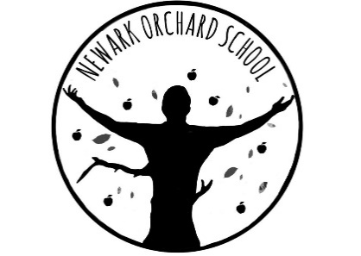
‘Individual Growth, Individual People’

Head Teacher: Mrs M A Tyers
London Road, Balderton, Newark, Notts NG24 3AL
Telephone: 01636 682255
Email: office@newarkorchard.notts.sch.uk
Website: www.newarkorchard.notts.sch.uk

Wednesday 20th April 2022

Dear parents & carers,

I hope you have all had a good Easter break and it was lovely to welcome all the pupils back yesterday. I have included in this letter the latest guidance on COVID 19 to ensure you are well informed about the school’s response to the Government guidance.

Respiratory Health and Attendance at School

From 19 April 2022 we will be following the ‘Living with COVID’ approach, as set out by the Government. As you might expect, we have had to tailor this approach specifically for our school population.
The first thing to note, is the national guidance now covers ‘People with symptoms of respiratory infection, including COVID-19’. Respiratory infections can spread easily between people. It is important to be aware of symptoms so you can take action to reduce the risk of spreading infection to other people.

Testing

Routine and confirmatory testing for COVID-19 has stopped in England. We are no-longer able to get testing kits for use by pupils or staff. It is therefore vital we all remain alert to the symptoms of respiratory infections, including COVID-19 and follow the guidance highlighted below.

Symptoms

The symptoms of COVID-19 and other respiratory infections are very similar. It is not possible to tell if you have COVID-19, flu or another respiratory infection based on symptoms alone. Most people with COVID-19 and other respiratory infections will have a relatively mild illness, especially if they have been vaccinated.

Symptoms of COVID-19, flu and common respiratory infections include:
· continuous cough
· high temperature, fever or chills
· loss of, or change in, your normal sense of taste or smell
· shortness of breath
· unexplained tiredness, lack of energy
· muscle aches or pains that are not due to exercise
· not wanting to eat or not feeling hungry
· headache that is unusual or longer lasting than usual
· sore throat, stuffy or runny nose
· diarrhoea, feeling sick or being sick

If your child is feeling unwell with these symptoms, you should get plenty of rest and drink water to keep hydrated. You can use medications such as paracetamol to help with your child’s symptoms. Antibiotics are not recommended for viral respiratory infections because they will not relieve symptoms or speed up recovery.

In some cases, you might continue to have a cough or feel tired after your other symptoms have improved, but this does not mean that you are still infectious.

You can find information about these symptoms on the NHS website. If you are concerned about your symptoms, or they are worsening, seek medical advice by contacting NHS 111. In an emergency dial 999.

When children and young people with symptoms should stay at home and when they can return to education

Children and young people with mild symptoms such as a runny nose, sore throat, or slight cough, who are otherwise well, can continue to attend their education setting.

Children and young people who are unwell and have a high temperature should stay at home and avoid contact with other people, where they can – please do not send them to school. They can go back to school, and resume normal activities when they no longer have a high temperature, and they are well enough to attend. If your child is unable to communicate how they are feeling, we will use our knowledge and judgement to try our best to ascertain their wellness.

All children and young people with respiratory symptoms should be encouraged to cover their mouth and nose with a disposable tissue when coughing and/or sneezing and to wash their hands after using or disposing of tissues.

Children and young people aged 18 years and under who have a positive test result

It is not recommended that children and young people are tested for COVID-19 unless directed to by a health professional.

If a child or young person has a positive COVID-19 test result they should try to stay at home and avoid contact with other people for 3 days after the day they took the test, if they can. After 3 days, if they feel well and do not have a high temperature, the risk of passing the infection on to others is much lower. This is because children and young people tend to be infectious to other people for less time than adults.

Children and young people who usually go to school, college or childcare and who live with someone who has a positive COVID-19 test result should continue to attend as normal

How to reduce the spread of infection:

There are several things we can do to reduce the spread of infection:

· Limit close contact with others.
Spend as little time as possible in communal areas.
· Regularly clean frequently touched surfaces and shared rooms
· Wash your hands regularly using soap and water
· Keep rooms well ventilated.
· Catch coughs and sneezes in disposable tissues and put them straight in the bin.

I hope that the information in this letter is clear but should you need any further explanation then please do not hesitate to contact school.

Yours sincerely,

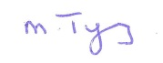
Margot Tyers
Head Teacher

