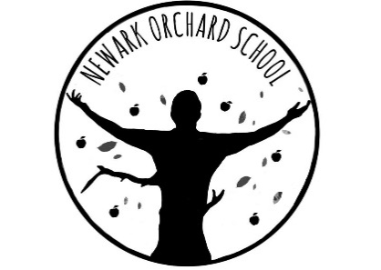
‘Individual Growth, Individual People’

Head Teacher: Mrs M A Tyers
London Road, Balderton, Newark, Notts NG24 3AL
Telephone: 01636 682255
Email: office@newarkorchard.notts.sch.uk
Website: www.newarkorchard.notts.sch.uk

Newark Orchard School originally opened in 1996 and was based across two sites. In September 2020 the brand new, state of the art building opened on London Road site in Balderton catering for 140 pupils from ages 3-18. As a generic special school, we provide an education for a wide range of needs. The facilities include a hydrotherapy pool, an Immersion room, a sensory room a soft play room and specialist curriculum rooms amongst many others. The school also has a Specialist Autism Hub as part of the new building.

At our last Ofsted inspection in June 2019 we were judged to be a good school with outstanding features. We are fully committed to ‘Individual Growth for Individual People’. We have a very experienced and skilled staff and we pride ourselves on our abilities to construct Individual Education Programmes and personalise the curriculum to meet the requirements of young people with special educational needs and enable them to access their curriculum entitlement. We are delighted to work with schools across Newark to enhance their special educational needs provision. We are happy to offer advice and support wherever requested. We work with a whole range of different professionals and enjoy a close partnership with them. We are totally committed to helping to maintain appropriate provision for individual pupils, wherever they go to school.

Further information about Newark Orchard School can be found on our website – www.newarkorchard.notts.sch.uk

