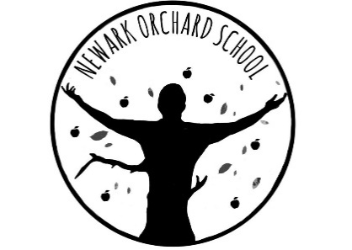
‘Individual Growth, Individual People’

Head Teacher: Mrs M A Tyers

Friday 29th January 2021

Dear Parents/Carers,

Remote Education Provision

This information is intended, alongside the Policy available on the website, to provide clarity to parents or carers about what to expect from remote education during a national lockdown or where bubbles are required to remain at home and self-isolate.

If a pupil is at home during this National Lockdown or has a period of isolation, we are committed to ensuring that they are receiving support for their education and well-being.

For children who have special educational needs home learning will largely be through support from parents/carers. For our pupils we believe it is best to support their individual needs. This does take more time to get things right but we believe this is essential to enable children to have the right home curriculum and also each family to have the best support matched to themselves.

Below we have outlined what is already in place. However, it is important that parents/carers continue to talk to the teacher about any queries or worries and of course the things that are going well. It is also really important to stay in touch and respond to communication so that we know you and your child is safe and well. If we don’t hear back from you then we have a duty of care to chase this up.

What is in place to support Remote Learning for pupils who attend Newark Orchard School?
All parents and carers are sent packs containing suggested activities for home that will support their child’s progress towards their targets. These are either shared via email or printed out for ease of access.
If any parent or carer needs any further resources to support the work provided then they are asked to discuss this with child’s teacher.
Teachers will talk to parents and carers each week and if the outcomes have been achieved or if the work needs amending then this can be done.
When designing the activities, teachers have tried to ensure the resources needed are items that will be available in the home. All family homes are different so if you do need support with any of the resources then let them know. Online activities

Everyday activities and a daily learning routine
For our pupils, learning will not only take place when they access activities from the learning packs or online activities. For our pupils, learning takes place throughout the day. Mealtimes will provide excellent opportunities for personal development e.g. eating and drinking, sitting, waiting, taking turns and also communication and understanding. Personal care routines such as bathing and cleaning teeth are again all opportunities for learning as are other important life skills.
Each pupil, learning in school is broken down into manageable chunks, linked to attention levels. Time for independent exploration, play and leisure is also an important aspect to learning.

How will work and progress be assessed?
The teacher can talk to a parent and carer about what their child has achieved, made progress with or found difficult. They can help to break learning down into small steps and suggest next steps when your child has achieved what they are working on.
Parents and carers can share photographs if they wish and advice has been given on how this can be done. Teachers are starting to do ‘Live Lesson’. through Teams and where appropriate this may be a means of sharing work and achievements

Wellbeing and Safety
The well-being and safety of our pupils and families is of paramount importance. Teachers will contact families whose children are not attending school during this Lockdown period due to families wanting to keep their children at home. Teachers will be liaising with senior staff in school if parents/carers have any concerns. School will also liaise as necessary with other linked professionals. The school Safe-guarding Policy remains in place during this period for all pupils.

Online Learning
The school website is in the process of having links added to several online sites or apps that may be useful in supporting your child’s learning. This can be found on the Covid-19 page with other important information and guidance. The school’s Face Book page is also used for teachers to upload photographs of completed work and for ‘Singing Assemblies’ and ‘Sharing Stories’

Live Lessons
The school is developing the home learning offer to include some ‘Live Lessons’ with the teacher to support their work. Attached to this letter is an agreement which needs to be read, signed and returned before your child is able to access the lessons.

Access to Devices
As you are aware the DFE have provided a small number of devices for schools to loan out to pupils who do not have access to a suitable electronic device. The devices will be available from Monday 1st February for selected parents/carers to collect and sign the loan agreement. The school will be in touch with those families involved in this scheme.

I hope that this letter provides an overview of the school’s remote learning offer and explains our aims and ambitions for supporting our pupils working at home. Please let us know if you require further support or to share successes.

Thank you for your on-going support during this challenging time and keep safe and well.

Yours Sincerely,

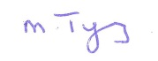
Margot Tyers
Head Teacher

London Road, Balderton, Newark, Notts NG24 3AL
Telephone: 01636 682255
Email: office@newarkorchard.notts.sch.uk
Website: www.newarkorchard.notts.sch.uk

