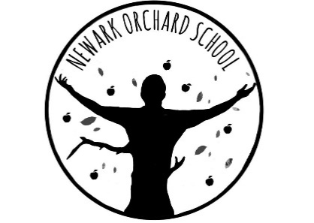
‘Individual Growth, Individual People’

Head Teacher: Mrs M A Tyers

Newark Orchard School Remote Learning Agreement

To support our students further in their Home learning, we are introducing teacher led group lessons via Microsoft Teams. This will enable your child to access

Parental Consent and Behaviour Agreement

It is vital for everyone’s safety and wellbeing that Microsoft Teams is used appropriately and we ask parents and carers to read the following points carefully and to discuss these with your child:

- All ‘live lessons’ will be held through Microsoft Teams.

- All live lessons will start after 8.45am and end before 3.15pm.

- Students should take part in live lessons somewhere near enough for you to monitor, yet private enough for them to concentrate on their work.

- It is not appropriate for parents/carers to take part in lessons unless invited to do
- Live lessons should not take place in a student’s bedroom.

- Students/parents/carers must ensure that there are no distractions whilst on a live lesson e.g. Mobile phone, TV etc

- Students/parents/carers should be mindful about what family activities would potentially be heard during the students’ use of live lessons

- Students must listen to instructions and disable their microphone unless asked to enable it by the teacher.

- All backgrounds should be blurred when taking part in live lessons

- All live lessons will be recorded. This means that they will be accessible later, so that all students have equality of access and opportunity, should they not be able to access the lesson at the time. Recording of all live lessons protects everyone.

- The school has ensured that online learning tools used during the COVID-19 pandemic are in line with data protection and GDPR policies.

- Students/parents/carers should not take photos, screenshots, record any video, or audio, from these live lessons or attempt to live stream it from their mobile phones.

- The same rules of conduct and behaviour will apply as in the classroom. Students should be polite and respectful at all times.

- Any breaches of the points above will result in students being immediately removed from the lesson.

- Students will only log on to the school computers with their own school user name and password and will not change the password

- Students are responsible for all activity carried out under their username.

- Students will only use the school e-mail address for school related work and they understand that teaching staff will regularly monitor these.

- Students will not deliberately browse, download or forward material that could be considered offensive or illegal. Students will tell a trusted adult if they accidentally click on inappropriate material

- Students understand that these rules keep them safe and if they are not followed there will be consequences and parents/carers contacted.

- Students will only be allowed to take part in live lessons if the consent form and agreement below has been completed and returned to school.

Parent/Carer Consent

I agree to all of the above terms and will support my child to abide by them

Signed…………………………………………………….

Date……………………………………………………
Student agreement

I agree to the above terms and will behave in a safe and appropriate way

Signed……………………………………….

Date………………………………………….

London Road, Balderton, Newark, Notts NG24 3AL
Telephone: 01636 682255
Email: office@newarkorchard.notts.sch.uk
Website: www.newarkorchard.notts.sch.uk

