 | Sensory Time | Good Morning Time |  | Playtime | Snack Time |  | Dinner Time | Sensory Time | Personal, Social, Emotional Development |  | 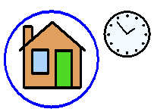  Home time
 |  |  | 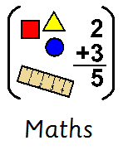 |  |  |  |  |  | 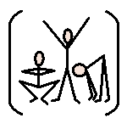  Physical Development |  | Home time
 |  |  |  |  |  |  |  |  | Understanding of the World  (Geography, History, Science, RE, Computing) |  | Home time
 |  |  |  |  |  |  |  |  | Expressive Art and Design  (Art, DT, Music) |  | Home time
 |  |  | 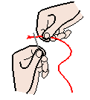  Fine Motor Skills |  |  | 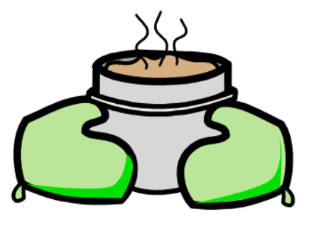  Baking |  |  | Swimming | 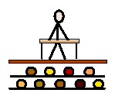  Pupil of the Week Assembly | Home time
Throughout the day there are always opportunities built in to every session for the pupils to communicate and express their wants. This is usually in the form of the Picture Exchange Communication system (PECS) but other communication methods are adopted to suit the individual need of each pupil.

