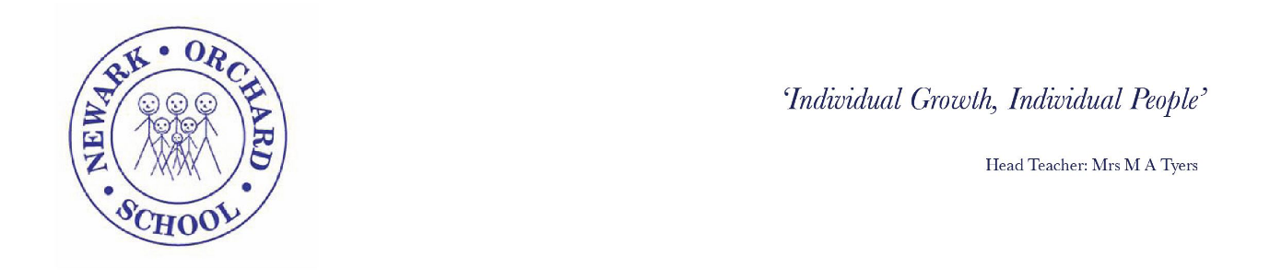

Monday 1st June 2020

Dear Parents/Carers,

I am writing to update you on the latest developments regarding the proposed wider re-opening of schools. I received an email late on Friday afternoon from Notts Local Authority stating that the Trade Unions ‘remain seriously concerned about the readiness of all schools to open more widely from 1st June 2020’. In their view ‘no school could open safely to more children at this point in time and they will communicate with each school opening with a view to escalating concerns to the Health & Safety Executive and to the press’
It is with regret that we have now had to re-consider our decision to open the school to more pupils at this time. All staff and Governors have been in full support of our plans so far and we have followed all Government guidance and are confident that we have a robust risk assessment in place to ensure we can provide a safe learning environment.
We will continue to offer provision for all keyworker children and those most vulnerable who cannot be cared for at home. The pupils who are effected by this delay have been contacted by telephone this afternoon.
I will keep you updated and will be in touch with any further developments as soon as I can.

Yours Sincerely,

Margot Tyers
Head Teacher

