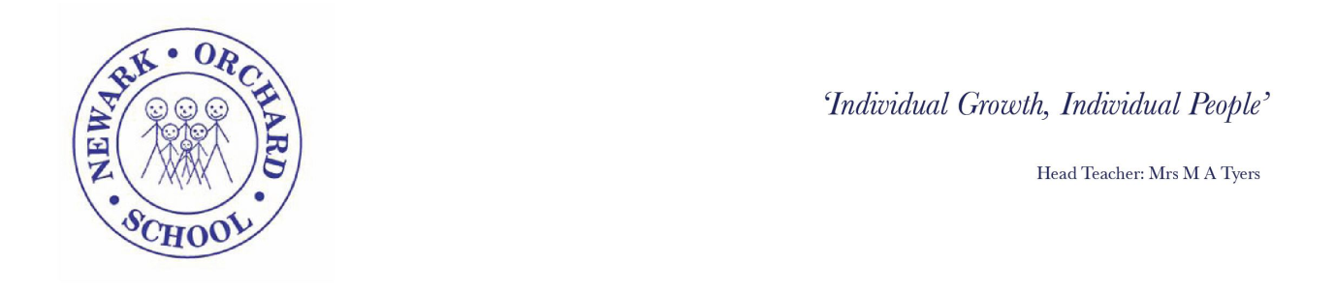

School Place Questions

Child’s Name:

You will have heard the government talking about their plans for children to return back to school. We know pupils won’t all be coming back straight away, or at the same time. We want to gather your thoughts and information, so that we can make decisions about our next-steps. The year groups stated by the government do not apply to special schools. The cohorts will be decided by the school once a risk assessment has been carried out. If following the completion of the risk assessment we feel it is safe to do so we will plan a gradual increase in numbers and share our plans with you.

In order to do this please can you return your completed questionnaire as soon as possible.

- Would you want your child to begin to attend school from 1st June 2020
  - Yes, fulltime
  - Yes, part-time
  - No, not at the current time

- How would you describe your child’s vulnerability to Covid?

  - Extremely vulnerable (at higher risk of fatal illness resulting from Covid)
  - Clinically vulnerable (at higher risk of severe illness due to pre-existing condition )
  - Typically, vulnerable (at the same level as any other child)

- Has your child or anyone in the household received a shielding letter, or been instructed to self-isolate by an NHS professional?
  - Yes b. No

- How would your child follow social distancing and hygiene guidance?

  - Independently
  - With prompts or reminders
  - With physical support
  - It would not be possible to undertake social distancing

- Would your child’s condition mean that staff would have to work within their personal and/or intimate space to provide personal or medical care?
  - Yes b. no

- Would your child’s behaviour mean that staff could have to work within their personal and/or intimate space to support their behaviour or keep them/others safe?
  - Yes
  - No

- Are you able to transport your own child to school, to reduce the risk of transmission?
  - Yes
  - No

- Are you able to continue to meet your child’s needs (as per the EHCP) at home?
  - All of the provision
  - Most of the provision
  - Some of the provision
  - Little/none of the provision

- Do you require a school place because you need to return to work and there is no one in the household who can care for your child?
  - Yes
  - No

- Are you considered an essential worker?
  - Yes
  - No

- If your child displays corona-virus symptoms at school, are you able to collect them as quickly as possible?
  - Yes
  - No

- Would your child tolerate/be comfortable with staff wearing face masks and other protective equipment while supporting them?
  - Yes
  - No

Thank you for your cooperation, we will let you know our plans as soon as we have finalised them. Anything we do put together will of course be informed by the government meeting the required R rate during the next 2 weeks.

