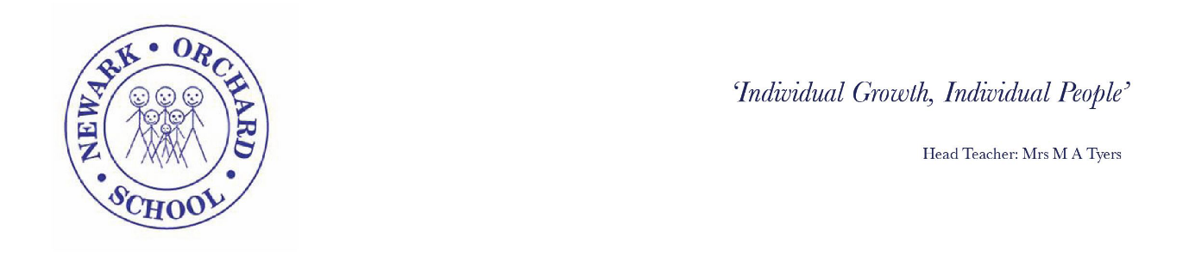Friday 22nd May 2020
Dear Parents & Carers,
I am writing to let you know our plans for after the half term break on the condition that the Government make the announcement that the R rate is such that it is safe to go ahead with plans to re-open schools.
As you will be aware a questionnaire was sent out to most households to gather relevant information. Thank you to those who have completed them as it has really helped in our planning. Based on this information we have put an initial list of pupils together. In order to ensure that we minimise risk and keep everyone as safe as possible we have carried out the recommended risk assessments. If you have made the decision to keep your child at home the school will continue to provide remote support as we have done over the last few weeks. If at any time you feel that you would like your child to return then please contact school to discuss this before sending your child back.
As there are only 24 pupils in school we will not be opening the London Road Site at this time, all the provision will be delivered from our Town site. If numbers increase to a point where we cannot maintain the safe movement around school without mixing then we will make the decision to re-open the site and let you know.
The children who have been attending since the lockdown will continue to attend as normal and will not have received a questionnaire as it is not necessary to complete one as we have assumed that you will continue to require a place.
County Transport have implemented safety measures which adhere to government advice which states that if you can transport your own child then it is recommended that you do so to limit the numbers of pupils on the bus and to allow for social distancing measures to be applied. If you have indicated on your questionnaire return that you can then we will assume that you will not require transport.
If you are transporting your child then please can you follow the social distancing advice and not enter the building unless invited to do so and please do not arrive early and congregate together outside the school as this will increase the risk of cross contamination. We really appreciate your support with this as it is in the best interests of the children and staff.
In order for the staff to prepare the classrooms, receive relevant coaching and familiarise themselves with the safety measures outlined in the risk assessment, the school will be closed to all pupils on Monday 1st June and will re-open on Tuesday 2nd June 2020
I do appreciate that this is a worrying time for everyone but we have put in place all of the recommended precautions to make it as safe as possible and minimise the risk for everyone.
Thank you again for your support and please continue to stay safe
Best Wishes

Margot Tyers
Head Teacher

