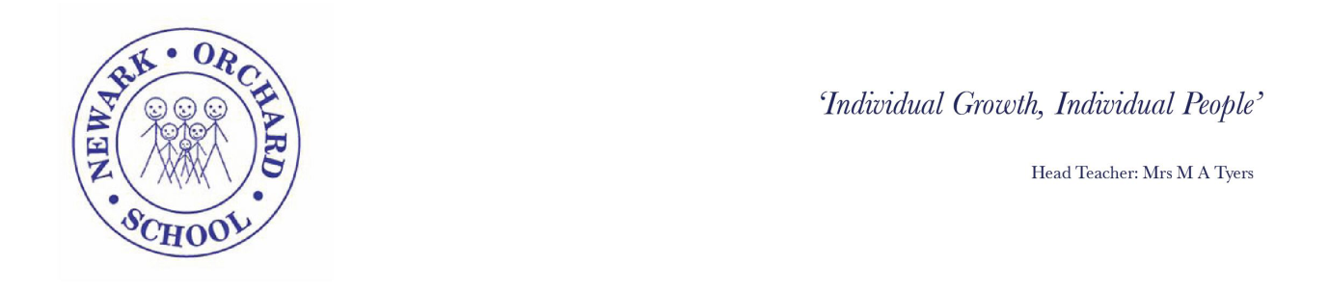
Wednesday 15th April 2020
Dear Parents and Carers,
I hope that this letter finds you all safe and well and that the current COVID -19 crisis has not directly affected you or your family’s health.
As you will be aware the current situation with schools being closed continues to be in place and is on-going for the foreseeable future. We are required to follow government direction in order to ensure we are doing everything we can to limit the spread of the virus. To this end I am writing to confirm that the school will continue to only offer places to children of Key Workers and those children who cannot be cared for safely at home. The advice remains clear that if a child can be cared for at home then this is the safest option.
I do appreciate that this current situation is difficult and that it must be putting pressure on all families, particularly those with children who have additional needs but hopefully if we can continue to follow the directions from the government then this crisis will be over sooner than later.
As a reminder if anyone in your household has symptoms of Corona then please follow the 14 day self- isolation guidance for the whole family and keep everyone safe. We do need to know if any family develops symptoms in order to put into place the correct cleaning schedule to limit the chances of spreading the virus to others if your child has been attending school.
Please can you contact school by email if you require a place for your child from Monday 20th April 2020 in order for us to put the correct staffing in place.
Please keep safe and I look forward to when this crisis is over and we can open our doors to welcome everyone back.
Yours sincerely

Margot Tyers
Head Teacher

