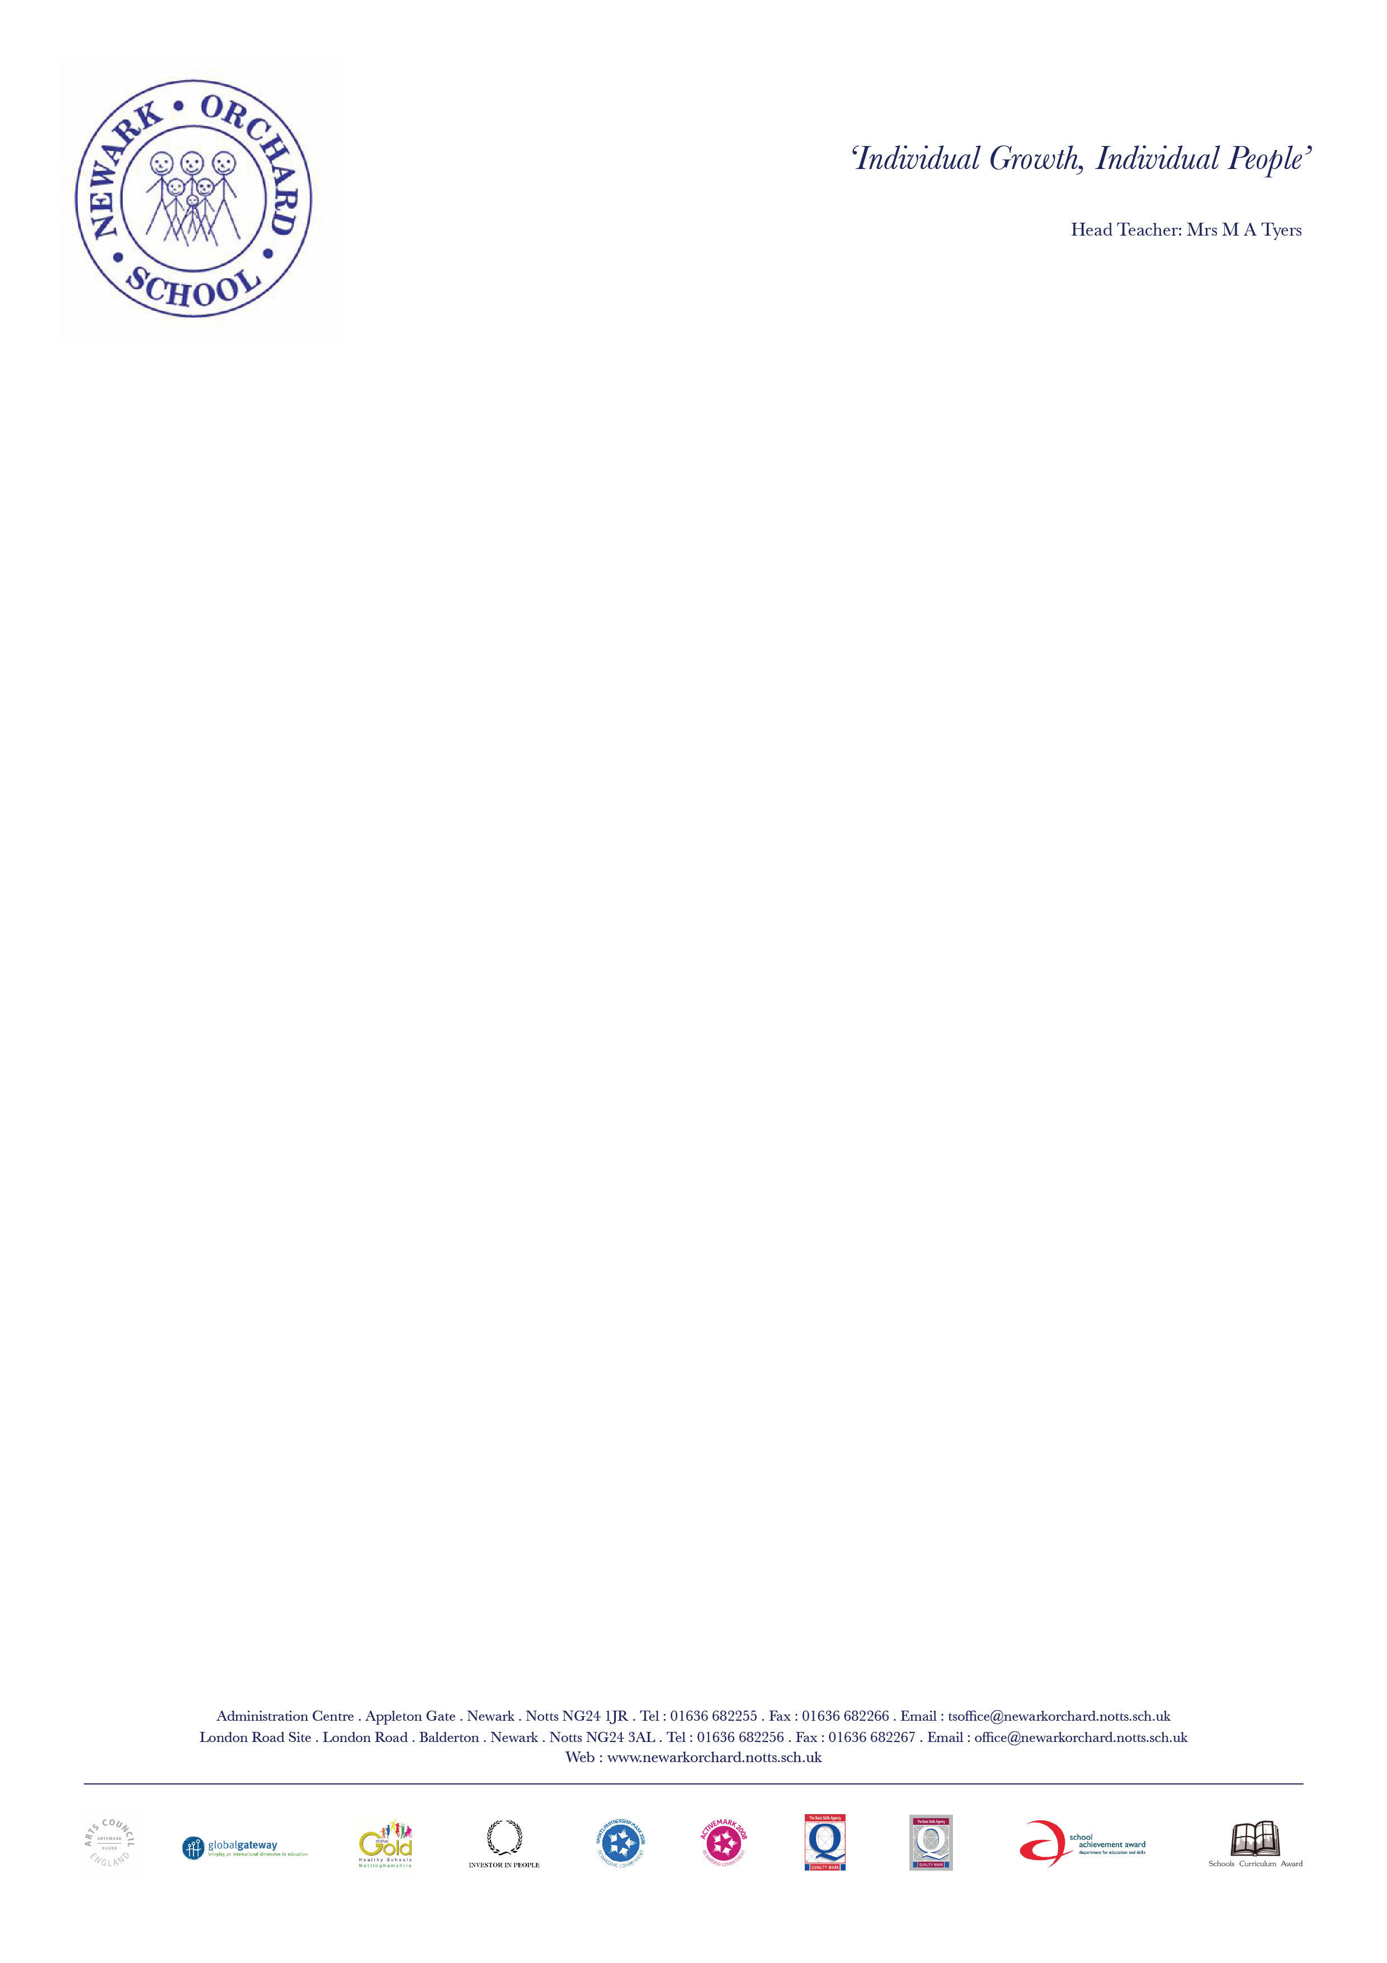

Newark Orchard School opened in 1996 and is an Area Special School across two sites. The 3-14 Department is on Appleton Gate in the centre of Newark and the 14-18 Department is based on the London Road at Balderton. We also have a Specialist Autism Hub which is based on Town site. The school is in the process of being rebuilt on one site with the potential to grow to 140 places.

At our last Ofsted inspection in June 2019 we were judged to be a good school with outstanding features. We are fully committed to ‘Individual Growth for Individual People’. We have a very experienced and skilled staff and we pride ourselves on our abilities to construct Individual Education Programmes and personalise the curriculum to meet the requirements of young people with special educational needs and enable them to access their curriculum entitlement. We are delighted to work with schools across Newark to enhance their special educational needs provision. We are happy to offer advice and support wherever requested. We work with a whole range of different professionals and enjoy a close partnership with them. We are totally committed to helping to maintain appropriate provision for individual pupils, wherever they go to school.

Further information about Newark Orchard School can be found on our website – www.newarkorchard.notts.sch.uk

