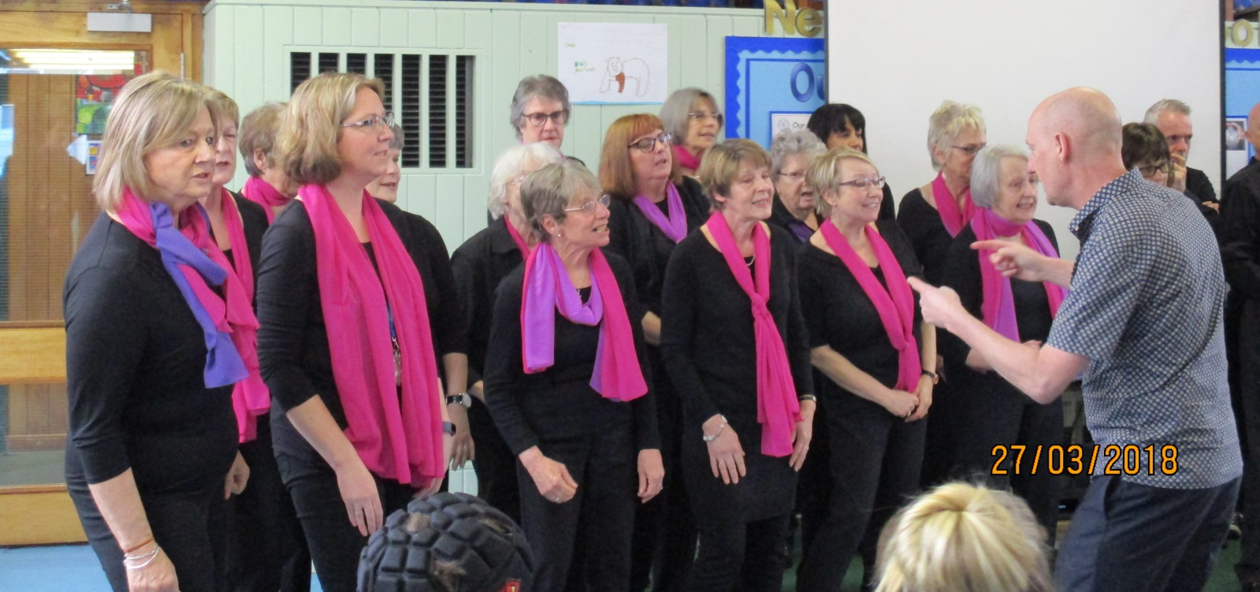

On Wednesday 27th March, the West Bridgford Social performed a number of songs at Newark Orchard School. The school was chosen as one of the choir’s charities for 2019 and has currently already raised over £1500! Jantine Nusselder is a class teacher at the school and is also a member of the choir.
Today the choir were invited to meet the students of Newark Orchard School. They started the day by listening to a performance from ‘the Saplings’, the school’s very own choir, led by Claire and Janet. The two choirs then worked with the Social Singer’s Musical Director Simon Thompson on various fun warm up songs, accompanied by Joan Jamieson on the piano.
The workshop with the Saplings was uplifting and fun. The students very much enjoyed performing to a proper audience and Claire told me that the children sang the best they’ve ever had. Janet said that it felt very special for the Saplings to be the only students involved in the morning workshop.
One student, who never normally joins in with singing during choir rehearsals, certainly came out of her shell this morning.
The rest of the school then came into the school hall and performed a recently learnt song, ‘True Colours’. The students used Makaton Sign Language to accompany the song.
Finally the choir performed a selection of songs from their repertoire to all the students and staff in the school hall.
I have to say that I have rarely seen the students so engaged and quiet. The music clearly had a fantastic effect on them and many had an overwhelming need to applaud us after the songs. Some students got so excited and clapped above their heads to show their appreciation.
A teaching assistant said that one student was particularly engaged during our African songs. It clearly struck a chord with her.
One student normally refuses to come into the hall during singing assemblies, but this time she attended and said that she enjoyed the singing.
So many staff members came to see me today to say how much they enjoyed our visit. It really meant a lot to all of us. One said ‘Amazing! Please let them come back.
The Friends of Newark Orchard School, who have done a tremendous amount of fundraising for our school over the years, then invited the two choirs for coffee and home-made cake.
The West Bridgford Social Singers very much enjoyed their visit to Newark Orchard School and enjoyed meeting the students. They will continue to raise funds throughout the year by performing in various locations in and around Nottingham. These funds will be used for resources in the new school, due to be complete in Summer 2020.

Feedback from the West Bridgford Social Singers:
- I just wanted to say what a joy and a privilege it was to take part in everything that took place this morning. Thank you so much for having the vision and for working so hard to make it happen. I do hope that this is just the beginning of a long relationship with the students, staff and friends of Orchard School. ...........and I look forward to learning more 'signing' !! Lynne x

- Thanks for organising today. Everyone really enjoyed working with your students. They are a credit to you. From Joan Jamieson

- Just a quick note to thank you all for your support for our nominated charity, Orchard School in Newark. The way in which you integrated in the warm-up activities and worked with the children was really heart-warming. They had fun. The Saplings were excellen. Super performance and workshop engagement. Similarly, the performance was also very good - enaging and varied - From an elephant to a shuffle, from a signing river to choral classics. The children were a credit to school and Jantine, and the staff and Friends of the School made us welcome, and provided lovely cake. We should return to Orchard, shouldn't we! Today made a difference to many, pupils and singers alike. From Simon Thompson

- What a brilliant time we had today. It was a real pleasure to perform for your school. The Saplings were amazing and the whole school had such a wonderful atmosphere about it. Well done for all your organisation and hard work in getting it together. The kids were so well behaved. Look forward to our next concert. From Ariane.

